Confidentiality Level |  | BL - Restricted for internal use | TC ID / Revision |  | 00274622/C
Document Status |  | InApprovalProcess | Document No. |  | N/A
WBS code |  | 3.2.0.0 - L2 system
PBS code |  | RA1.L2.L2_1.PL.FE.PA3.DRV
Project branch |  | Engineering & Scientific documents (E&S)
Document Type |  | Specification (SP)
[RSD product category B]

Pump diode module for half Joule multipass amplifier
TP20_117



Keywords
Diode, DUHA, pump amplifier

 | Position |  |  | Name
Responsible person | Team Leader Scientific L2 |  |  | Jonathan Tyler Green
Prepared by | Team Leader Scientific L2 |  |  | Jonathan Tyler Green

RSS TC ID/revision | RSS - Date of Creation | RSS - Date of Last Modification | Systems Engineer
021475/A.001 | 22.07.2020 | 22.07.2020 | Amélie Grudinová
021475/A.002 | 30.07.2020 | 30.07.2020 | Denisa Hanusková
021475/A.004 | 5.8.2020 | 5.8.2020 | Amélie Grudinová
Reviewed By
Name (Reviewer) | Position | Date | Signature
Veronika Olšovcová | Safety Team Manager | Informed
Viktor Fedosov | SE and Planning Group Leader | Informed
Ladislav Půst | Manager Installation of Technology | Informed
Jack Naylon | Team Leader Laser beamlines control system group | Informed
Lucie Kaletusová | Clean Room Specialist | Informed
Pavel Bakule | Team Leader Scientific L1 | Informed
Jiří Kubricht | Lawyer | Informed


Approved by
Name (Approver) | Position | Date | Signature
Bedřich Rus | Scientific Coordinator of Laser Technology

Revision History / Change Log
Change No. | Made by | Date | Change description, Pages, Chapters | TC rev.
1 | J. Tyler | 17.07.2020 | Draft | A
2 | J. Tyler, A. Grudinová, J. Bartoníček | 30.07.2020 | Version for review | B
3 | A. Grudinová | 5.8.2020 | Version for author`s approval | C
4 |  |  | Final version for procurement | D

Table of Content

1. Introduction 4
1.1. Purpose 4
1.2. Scope 4
1.3. Terms, Definitions and Abbreviations 4
1.4. References to standards 5
2. Functional, Performance and Design requirements 5
2.1. General requirements for the module 5
2.2. Mechanical Requirements and constraints 8
2.3. Diagnostics and Control interface 11
2.3.1. Preferred implementation 11
2.3.2. Triggering 12
2.3.3. Controls interface to chillers 13
2.3.4. Fast amplitude control input control 13
2.3.5. Automation and Remote Control Interface 13
2.3.6. Machine Protection 15
2.3.7. Laser Safety 16
3. Delivery & Installation requirements 17
4. Safety Requirements 17
5. Quality Requirements 18
5.1. General Quality Requirements 18
5.2. Acceptance 18

Introduction

Purpose

This Requirements Specification Document (RSD) lists the technical requirements and constraints for the selection of a high energy, high average power pump diode module which is to be delivered to a laboratory at ELI Beamlines. This diode module will be used within the scope of the DUHA project.

Scope

This RSD contains all of the technical requirements: functional, performance and design, delivery, safety and quality requirements for the following product (tender number: TP20_117): Pump diode module for half Joule multipass amplifier (further “module”).

The diode will be in the L2 laser hall and will drive pre-amplifier the main pump laser for the DUHA beamline within the scope of the DUHA project. The products are registered in the PBS database under the following PBS code: RA1.L2.L2_1.PL.FE.PA3.DRV.

This product is a Category B product according to the ELI Beamlines RSD categories. The category B does not require any design modifications of the product. Delta verification (test) program shall be decided and performed on a case-by-case basis.
Furthermore, all items may be subject to testing and verification upon delivery to the ELI Beamlines facility by qualified personnel. All non-conformances (if any) must be addressed by the supplier in a timely manner.

Terms, Definitions and Abbreviations

For the purpose of this document, the following abbreviations apply:

Abbreviation | Meaning
ELI | Extreme Light Infrastructure
RSD | Requirements Specification Document
CA | Contracting Authority (Institute of Physics AV CR, v. v. i.)
FWHM | Full width Half Maximum
HR | High Reflectivity
TTL | Transistor–transistor logic
BNC | Bayonet Neill-Concelman coaxial connector
RMS | Root Mean Square
V DC | Volts, Direct Current
PLC | Programmable Logic Controller: a specific type of industrial ruggedized digital computer
LXI | LAN (Local Area Network) eXtensions for Instrumentation: a specific open standard for text-based instrument control over a network
TCP/IP | Transmission Control Protocol/Internet Protocol: a specific network communication protocol
OPC UA | OLE (Object Linking and Embedding) for Process Control, Unified Architecture: a specific machine-machine communication protocol
REST API | REpresentational State Transfer, Application Programming Interface: a specific web service architectural style
HTTP | HyperText Transfer Protocol: a specific web application protocol
Modbus | Modicon bus: a specific serial communications protocol
SCPI | Standard Commands for Programmable Instruments: a specific open standard for text based instrument control
JSON | JavaScript Object Notation: a specific open standard for data objects text representation
XML | Extensible Markup Language: a specific open standard for document markup
CDA | Clean dry air
PV | peak to valley

References to standards

If this document includes references to standards or standardized/standardizing technical documents the CA allows/permits also another equal solution to be offered. If a supplier offers another equal solution the CA shall not reject its bid, once the supplier by appropriate means in the bid proves that the offered supplies, services or works meet in an equivalent manner the requirements including references to standards or technical documents.

Functional, Performance and Design requirements

General requirements for the module

REQ-030389/A
The module shall meet the general requirements defined in
Table 1.

Table 1 Technical Parameters of laser diode modules
# | Parameter | Required value (description)
1.1 | Repetition rate (Hz) | 1 - 50, tunable  Nominal rep rate: 50 Hz
1.2 | Minimum pulsed peak power (kW) | 4
1.3 | Pulse duration (ms) | 0.8 – 1.0 tunable
1.4 | Central wavelength for average output powers between 160 W and 200 W (wavelength above and below which 50% of the total energy is contained), λ₀ (nm) | 940
1.5 | Maximum drift over 6 h in central wavelength after warm up for fixed duty cycle and pulse energy (nm) | ± 0.5
1.6 | Bandwidth | >30 % of total energy contained with ± 1 nm of λ₀  >70 % of total energy contained within -3.5 nm and +2.5 nm of λ₀
1.7 | Polarization | Horizontal with respect to optical table plane, 90 % polarization extinction ratio
1.8 | Distance to working plane from final optical element of pump coupling, i.e. folding mirror, imaging lens, etc. (mm) | >200
1.9 | Profile shape in working plane | Circular top hat, super-Gaussian
1.10 | FWHM diameter in the working plane (mm) | 5 ± 0.1
1.11 | Slope of spatial profile sides $\frac{Δr_{90\%-10\%}}{FWHM}$ | <5%
1.12 | Plateau homogeneity as percentage of plateau intensity (peak to valley) | 5%
1.13 | Beam height above table (mm) | 120 ± 1
1.14 | Temporal pulse shape (integrated over spatial profile) | Flat
1.15 | Rise/fall times of pulses (10% - 90% peak intensity) | < 60 μs
1.16 | Pulse to pulse energy stability for 10 000 pulses (PV with respect to the average of all pulses) | < 2%
1.17 | Long term average power stability (6 hour) measured with thermal power meter or shot to shot meter with 3 s moving average (PV) | < 3%
1.18 | Variation of instantaneous output power within the temporal plateau of the pulse at maximum output pulse duration and nominal output power | < 3%
1.19 | Spatial deviation of profile centroid position in target plane over 8h | < 0.5 mm

Figure 1 The desired spatial profile is a circular super-Gaussian. The cross section shown (not to scale) illustrates what is meant by the slope and plateau of the profile. The plateau is the area, concentric to the profile, which encompasses 75% of the energy of the beam. The slope is considered between 10% and 90% of the average intensity of the plateau. The FWHM is taken at the width at 50% the average intensity of the plateau.

REQ-030390/A
The performance and stability parameters of the module specified in Table 1 shall be satisfied for the following ambient environmental conditions and lab infrastructure:
- Room temperature 20 °C, stability ± 0.5 °C, humidity 50 %
- Facility water provided to chillers: 16 °C, inlet pressure max 5 bar on input, differential pressure between input and output: 1.5 bar
- CDA purity: Class 1:1:1 by ČSN ISO 8573-1:2013 (equivalent to ISO 8573-1:2010), pressure adjustable up to 6 bar, flow adjustable up to 100l/min (preferred interface is Swagelok compression fitting or G1/4 female parallel thread)
REQ-030391/A
The plateau of the beam profile (referred to in subsequent specifications) shall be defined as the circular area of the spatial profile concentric with the center which contains 75% of the integrated total energy of the profile. See Figure 1.
REQ-030392/A
Spectral, spatial and temporal characteristics and stability as defined in Table 1 shall be satisfied simultaneously over the full range of required repetition rates and pulse durations specified in Table 1.
REQ-030393/A
The parameters in Table 1 shall be taken after the final optical element of the module.
REQ-030394/A
The full divergence angle in a region extending ±200 mm around the target plane in both horizontal and vertical direction shall be no more than 8.5 degrees in order to avoid clipping on dichroic mirrors. The situation is sketched in Figure 2. The divergence angle is given by the change of the beam width over distance, with the beam width defined as that containing 95% of the total energy. In the bid, the supplier shall provide calculated intensity distributions for:
- the near field beam profile in the target plane
- near field ±15 mm away from the target plane
- far field
- a calculation of the beam diameter between the final optical element of the module and the working plane.

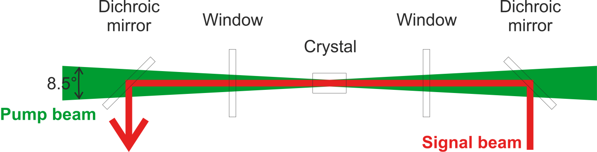

Figure 2 Pump beam’s divergence (for dimensions see Figure 3).

REQ-030396/A
- Diodes shall be tolerant of optical feedback at the operation wavelength (940 nm) of up to 10% of the maximum output power without degradation of performance.
- Diodes shall tolerate feedback in the form of a collimated 1030 nm laser beam with a circular profile, 5 mm in diameter, with a pulse duration down to 5 ns and pulse energy up to 1 mJ. To achieve this, the exit windows of the diode modules should have HR coatings (R>99%) at 1030 nm ± 2 nm, and should be tilted by at least one degree relative to the optical axis.
NOTE: The source may be exposed to on-axis optical feedback both at the pump wavelength and at 1030 nm.

Mechanical Requirements and constraints

REQ-030397/A
The pump beam shall be split by a 50/50 beam splitter and guided to the laser head with folding mirrors as proposed in Figure 3.

REQ-030398/A
The module and all optical elements (apertures, imaging lenses, folding mirrors, etc.) which are not an integral part of the module shall fit within a rectangular space with its size and position with respect to the crystal head sketched in the layout in Figure 3. The position of both dichroic mirrors with respect to the crystal head is fixed. No optical element is allowed between each of the dichroic mirrors and the crystal head.

REQ-030399/A
A thorough description of an alignment procedure shall be provided also explaining how positions and mutual distances of coupling optics affect the beam size at the working plane and divergence.
REQ-030400/A
All optics between the diodes and the dichroic mirrors before the laser crystal shall be provided by the supplier. These optics shall be mounted on suitable posts which can be rigidly clamped to the table. All materials required for clamping to the table must be provided.
REQ-030401/A
Suitable cables or conductors with minimal length carrying the pulsed diode current shall be easily connected/disconnected, unless the source and the pulsed power supply form an integrated unit that does not need to be disassembled for transport. The layout of supporting electronics for pulsed power supply shall be agreed upon with the CA. All cables should be shielded to reduce electromagnetic emissions. Cable lengths from the rack mounted power supply to the diode should be 12±0.2 m in length.
REQ-030402/A
The module shall be water-cooled (no fans are permitted). The temperature of the internal module cooling water cannot be outside the range of 19ºC to 32ºC.
REQ-030403/A
All additional equipment (e.g., power supply) shall be mounted in 19 in equipment racks and must consume no more than 10 U (Racks shall be provided by the Client). The maximum total heat dissipation into the air inside the racks must be less than 500 W per module. Water cooling should be used to reduce the air heat load of this equipment. The cable distance between these racks and the optical table is 12±0.2 meters.
REQ-030404/A
Microchannel water cooling should be avoided (i.e., all cooling channels and tubing shall be ¼ in inner diameter or larger).
REQ-030405/A
The chiller for the module will be provided by the CA and will be the model HIB RFCS-9HE.
REQ-030406/A
All connections between the module and rack mounted support systems shall be clearly labeled and straightforward to connect and disconnect.
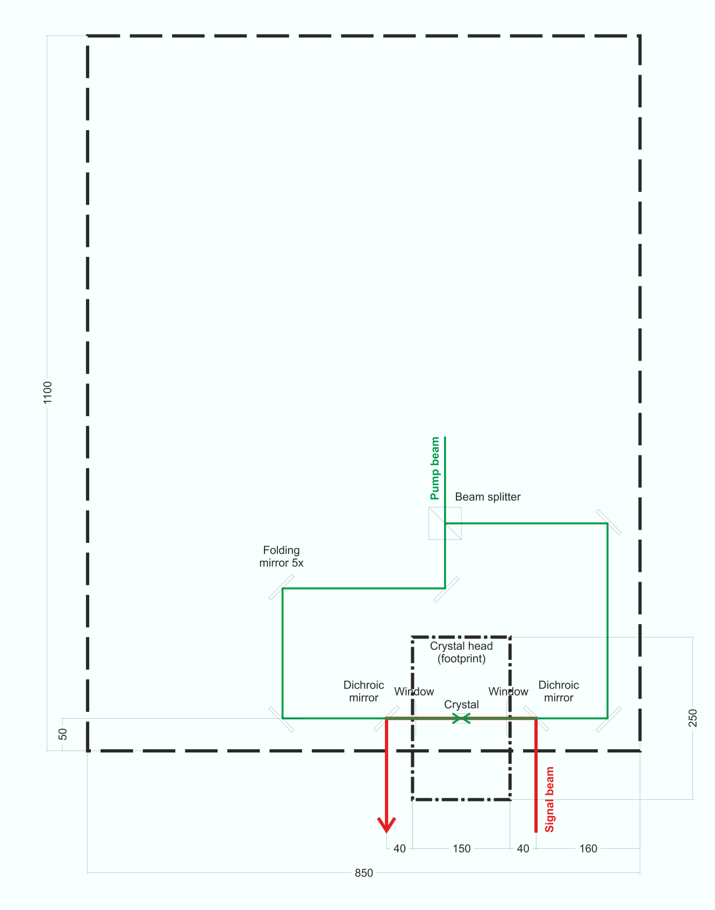
Figure 3 Amplifier head layout. The large rectangle (thick dashed line) with its size and position with respect to the crystal head (thick dash-dotted) delimits the space for placing the module and all other optical elements. Position of both dichroic mirrors with respect to the crystal head is fixed. Dimensions are in millimeters.

Diagnostics and Control interface
Figure 4: System integration block diagram with interfaces and scope definition

Preferred implementation

REQ-030407/A
The Pulser used in the diode module shall be a commercially available off-the-shelf single 19-inch rack-mount device no more than 2U high with water-cooling and safety interlock, front-panel key enable and E-stop push button, and front-panel display with manual control option. It must have an Ethernet control interface and must be compatible with the CA’s LabVIEW-based control system. Within two weeks from the signature of this Contract, the Supplier shall communicate to the CA, what specific product intends to use to fulfil the requirements mentioned above. The Supplier may proceed with the manufacturing only after such product is approved by the CA. The CA shall approve of the specific product only after the Supplier demonstrates to the CA that all the relevant requirements are met.
REQ-030408/A
The Power Supply used in the diode module shall be a commercially available off-the-shelf single 19-inch rack-mount device no more than 4U high with water-cooling and safety interlock, front-panel start and stop buttons, and a front-panel display with manual control option that can be disabled if remote control is used. It must have an Ethernet control interface and must be compatible with the CA’s LabVIEW-based control system. Within two weeks from the signature of this Contract, the Supplier shall communicate to the CA, what specific product intends to use to fulfil the requirements mentioned above. The Supplier may proceed with the manufacturing only after such product is approved by the CA. The CA shall approve of the specific product only after the Supplier demonstrates to the CA that all the relevant requirements are met.

REQ-030409/A
The controller shall perform all functions necessary for normal operation of the module that are not otherwise provided by other specifically labelled devices in Figure 4. The Controller shall be a commercially available off-the-shelf embedded controller with a real-time operating system and must include reliable FPGA-based processing of critical analog and digital signals. The Controller must have an Ethernet control interface and must be compatible with the CA’s LabVIEW-based control system. Within two weeks from the signature of this Contract, the Supplier shall communicate to the CA, what specific product intends to use to fulfil the requirements mentioned above. The Supplier may proceed with the manufacturing only after such product is approved by the CA. The CA shall approve of the specific product only after the Supplier demonstrates to the CA that all the relevant requirements are met.
REQ-030410/A
The CA shall provide reasonable assistance regarding the configuration and programming in LabVIEW of the Pulser, Power Supply and the Controller.

Triggering
REQ-030411/A
The module shall have a START trigger input compatible with TTL logic level signals with 50 Ohm BNC connector. The trigger input should be optically coupled for galvanic isolation. A rising edge on this trigger input shall cause the diodes to output a laser pulse of the pre-configured length (see Table 3), with the pulse leading edge aligned to this trigger with RMS jitter no more than 10 ns.
REQ-030412/A
The module shall support triggering at repetition rates defined in Table 1 including single-shot.
REQ-030413/A
The module shall not be damaged in the event of spurious triggering occurring at any repetition rate or by the sudden absence of one or more triggers at any repetition rate.
REQ-030414/A
When the module is not externally triggered, it shall be impossible by design for a laser pulse to be output (i.e., it must not be possible to accidentally set a self-triggered or CW mode or for the module to startup up in such a mode due to a fault).
REQ-030415/A
Regardless of any configuration settings on the pulse length, it shall be impossible to emit a pulse longer than 2 ms under any conditions (i.e., physical limitation, not software setting).

Controls interface to chillers

REQ-030416/A
The chiller providing cooling water to the module is out of scope of the supplier. The CA shall monitor all required chillers and shall be responsible for ensuring that the Machine Protection Enable (see § 2.3.6) input to the module is open-contact in the event that a fault with the chiller is detected. The Supplier shall ensure that no electronic interfaces between the chillers and the diode modules are necessary for full operation of the diode modules.

Fast amplitude control input control

REQ-030417/A
The relationship between the SETPOINT and the laser output peak power shall be given by a measured reference curve that shall be provided to the CA as part of the documentation, to an accuracy < 10% and repeatability < 3% over 6 hours. This accuracy must be maintained for at least 24 months from delivery or 1 billion shots (whichever is sooner).

Note: The scaling curve shall be fixed and not change if the Peak Power Limit (see Table 3) is changed.

Automation and Remote Control Interface

REQ-030418/A
The module shall be able to start up, initialize, operate, shutdown, and otherwise fulfil all requirements of this document, without requiring any direct manual user interaction (except for essential safety mechanisms, i.e., key switches and E-stops).
REQ-030419/A
All necessary operations required to use the module to its full capacity shall be performed via the Remote Control Interface. No HMIs, GUIs, touch panels, push buttons, control PCs, laptops, displays or similar are permitted to be required in order to use the module to its full capacity.
REQ-030420/A
The module shall be provided with a Remote Control Interface. This interface must allow the CA’s control system to monitor key system Status Variables (Table 2), set key Configuration Parameters (Table 3) and allow it to start and shut down the module remotely.
REQ-030421/A
The Remote Control Interface shall be Ethernet and use one of the following communications protocols/standards, in order of preference: LXI (TCP/IP), OPC UA (HTTP), REST API (HTTP), Modbus TCP/IP or ASCII-based string commands over TCP/IP or UDP. Commands and responses must be formatted as human-readable strings (e.g., SCPI, JSON, XML). Alternative communication protocols must be explicitly approved by the CA.
REQ-030422/A
Full documentation on the entire list of supported commands and responses from the device over the Remote Control Interface shall be provided to the CA, including any additional to those listed in (Table 2) and (Table 3).
REQ-030423/A
Status Variables (Table 2) shall be measured by the electronic controller and their values shall be updated and made available over the Remote Control Interface at the specified minimum update rate. Unless otherwise specified, all physical parameters reported must be accurately calibrated and within < 10% error of the real physical value when in an operational regime.
REQ-030424/A
If the Status Variables (Table 2) include an error code or error readout, a list of the possible error codes, their description and suggested remedial measures shall be provided to the CA in the Documentation.
REQ-030425/A
It shall be possible to read back any Configuration Parameter (Table 3) on demand via the Remote Control Interface.
REQ-030426/A
All Configuration Parameters (Table 3) shall be permanently retained and restored automatically in the event of a power cycle, with the exception Output Enable parameters, which must default to off/disabled on restoration of power.
REQ-030427/A
It shall be impossible to set a Configuration Parameter (Table 3) to a value that is outside of the achievable range or to a value that could cause damage to the module.
Table 2: Required Status Variables for readout via the Remote Control Interface
Category | Name | Description | Min. update rate | Format
Photodiodes | Output monitor | Optical power of the module output pulse | 10 Hz | Scalar numeric, with conversion to calibrated Watts peak
Temperature | Inlet cooling water |  | 1 Hz | Celsius, scalar numeric
Temperature | Outlet cooling water |  | 1 Hz | Celsius, scalar numeric
Temperature | Diode block | From sensor in direct contact with the diode emitters | 1 Hz | Celsius, scalar numeric
Enclosure environment | Dew point | e.g., readout from a Vaisala DMT152 sensor | 1 Hz | Celsius, scalar numeric
Enclosure environment | Air temperature |  | 1 Hz | Celsius, scalar numeric
Cooling circuit | Outlet flow switch |  | 10 Hz | Good/Bad status
General | Overall health status | Overall system health (or health of each system component independently) | 10 Hz | Good/Bad status, optional error code/description
General | Operational mode | One of a limited set of operational modes, e.g., Standby, Warmup, Ready, Error | 1 Hz | Short string from a finite, known set

Table 3: Required Configuration Parameters to be set via the Remote Control Interface
Name | Description | Format
Peak Power Limit | Configurable upper limit for the output pulse peak power (regardless of analog SETPOINT control value) | Calibrated Watts peak
Pulse Length | Configurable pulse length | FWHM in microseconds,
Output Enable | Enable or disable the emission of the main output beam | Binary enable/disable

Machine Protection
REQ-030428/A
The module shall have internal detection and protection against, or be inherently resistant to sustaining damage from, the following failure modes:
- Loss of cooling water flow or pressure
- Cooling water excess pressure
- Overheating or thermal runaway of diode stacks
- Condensation of water vapor in the housing
- Excessive humidity in the housing
- Leakage of cooling water into the housing
- Sudden loss of external power on any supply
- Sudden loss of any external control signal or interface
- Overvoltage or overcurrent of internal power supply
- Short-circuit or open-circuit fault of a diode stack
- Back reflections up to 10%
- Random failure of electronic controller
REQ-030429/A
The module shall include a Machine Protection Enable input. An externally provided closed contact (suitable for 24V DC signals) must be required at all times for the module to operate. Opening these external contacts must cause the module to stop operating within 10 ms of the open-circuit event. The preferred connector types for this interface are DSUB-9 female or M12 female. The CA will ensure that failures of externally provided services, such as cooling water or dry air, result in open-contact of this input.
REQ-030430/A
The module shall include a Machine Protection Fault output (or multiple outputs for every individual device). Internal dry contacts or a 24V DC signal output must be provided that are closed in normal operation and opened in the event of any detected internal fault, failure or off-normal condition. The preferred connector types for this interface are DSUB-9 or M12. Use of other connector type shall be discussed with the CA. The connector may be shared with the Enable input or it may be separate.

Laser Safety
REQ-030431/A
The module should be supplied as an ‘OEM component’ product requiring further integration into a laser system by the CA at their facility. Therefore, it may not be necessary for the module to satisfy the full regulatory safety standards that would be required for an off-the-shelf product.
REQ-030432/A
Upon delivery of the module to the CA, the CA has the responsibility to implement a laser safety interlock for use of the module in the CA’s laboratory in accordance with relevant standards from IEC 60825 series. The Supplier shall provide the CA with all necessary information about the module to ensure the compliance of the fully integrated laser system with these standards.

REQ-030433/A
The CA intends to satisfy laser interlock requirements by directly disconnecting the mains power to the module. It shall be physically impossible for the module to emit laser radiation in the absence of mains power.
REQ-030434/A
Sudden disconnection and restoration of the interlocked mains power to the module power supply shall not result in damage.

Note: an auxiliary non-interlocked mains supply may be provided to maintain power to electronic controllers and ancillary devices that do not produce a laser hazard. The chiller will also be provided with a dedicated mains power connection which will be UPS-backed. This requirement does not apply to either of this power supply.
REQ-030435/A
The Client shall supply power to the module in the format requested by the Supplier up to a maximum of four single phase 230 VAC, 16 A in accordance with Czech Republic national standards. Each circuit may be of interlocked or auxiliary type as specified by the Supplier in order to meet all laser safety requirements above. Each circuit will be fitted with a circuit breaker by the CA. The Supplier should not provide their own mains power distribution as part of the delivery.

Delivery & Installation requirements

REQ-030436/A
The transportation, to the final destination, installation and demonstration of functionality shall be conducted by the Supplier.
NOTE 1: The bid price will be considered by the CA as the final price, including transportation cost.
NOTE 2: The Supplier will provide all necessary documentation detailing procedures for safe and proper installation (see REQ-024525/A).

Safety Requirements

REQ-030437/A
The Supplier shall supply a Declaration of Conformity or any other equivalent document legally recognized and accepted in the Czech Republic for each product type if the appropriate legislation determines the Supplier's obligation to have a Declaration of Conformity (or the equivalent document) for the purposes of a Product sale in the Czech Republic to fulfil the requirements of 2001/95/EC directive or applicable Czech law.

Quality Requirements

General Quality Requirements

REQ-030438/A
The Supplier shall provide the Product Manual as part of the delivered Device. Completeness of the Manual shall be approved by the CA. The Manual shall include the instructions and descriptions regarding the following procedures:
- transport;
- handling;
- storage;
- installation;
- safe operation and maintenance procedures.
REQ-030439/A
The Supplier shall provide a declaration of conformity with technical requirements defined by the product RSD and ensure completeness of the products.
REQ-030440/A
The Supplier shall provide verification protocols outlining the results of tests executed for the module before its delivery at ELI Beamlines premises to confirm specification conformity (see REQ-030439/A).
NOTE: The content of the verification protocols shall be agreed with the CA.
REQ-030441/A
The Supplier shall establish and maintain a nonconformity control system compatible with ČSN EN ISO 9001 (or equivalent, e.g. EN ISO 9001) or equivalent.

Acceptance

Acceptance will be carried out by the CA upon delivery and final verification of the Tables at ELI Beamlines premises. The basis for acceptance will be verification protocols summarizing the overall verification results together with relevant documentation supporting the verification (see REQ-030438/A, REQ-030439/A, REQ-030440/A and REQ-030441/A).

In case of successful acceptance phase, the CA will provide to the Supplier signed acceptance protocol. In case of unsuccessful acceptance stage, the CA will provide to the Supplier Nonconformity Report (NCR) and process in accordance with
REQ-030441/A will be applied.

REQ-030442/A
The Acceptance phase shall demonstrate the following:
- Final Products have been successfully verified by the Supplier and the results of this process have been documented in an appropriate way through verification protocols (see REQ-030440/A);
- All detected nonconformities have been solved in accordance with REQ-030441/A;

