Confidentiality Level |  | BL - Restricted for internal use | TC ID / Revision |  | 00327567/C
Document Status |  | Document Reviewed | Document No. |  | N/A
OBS code |  | 914 L4 ATON Laser
PBS code |  | RA1.L4.CMP1.10PW.OM
Project branch |  | Engineering & Scientific documents (E&S)
Document Type |  | Specification (SP)
[RSD product category A]

Compact high-accuracy and high-rigidity piezo positioners with position encoders
TP22_009
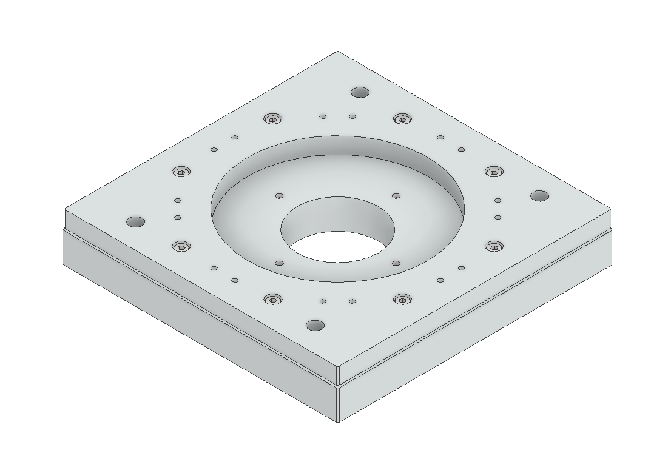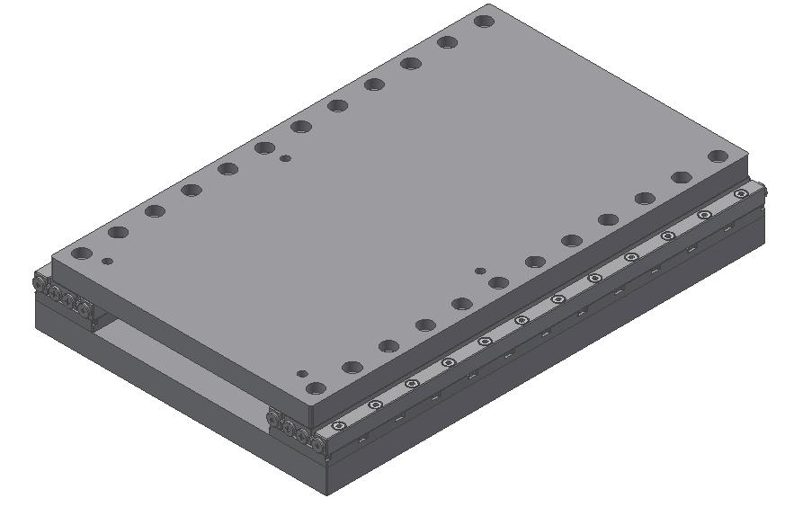

Keywords
N/a

 | Position |  |  | Name
Responsible person | Head of department of Laser Systems / Senior Scientist |  |  | Bedřich Rus
Prepared by | Research Assistant |  |  | Petr Szotkowski

RSS TC ID/revision | RSS - Date of Creation | RSS - Date of Last Modification | Systems Engineer
023544/A.001 | 16.2.2022 | 16.2.2022 | J. Adamec
023544/A.001 | 16.2.2022 | 18.2.2022 | J. Adamec
Reviewed By
Name (Reviewer) | Position | Date | Signature
Jack Naylon | Group leader of Laser Control Systems / Senior Scientist | INFORMED (Category A)
Martin Laub | Head of department of Construction and Design Support
Pavel Bakule | Group Leader of L1 Allegra Laser/ Deputy of Head of Department
Petr Brabenec | Designer
Radek Toman | Legal Group Leader
Birgit Plötzeneder | Central Control Systems Group Leader
Martin Tůma | Electrical Designer
Veronika Olšovcová | Group Leader of Safety
Viktor Fedosov | Group Leader of Quality and Planning


Approved by
Name (Approver) | Position | Date | Signature
Bedřich Rus | Head of department of Laser Systems / Senior Scientist | 21.2.2022

Revision History / Change Log
Change No. | Made by | Date | Change description, Pages, Chapters | TC rev.
1 | P. Szotkowski,  P. Tůma | 15.2.2021 | RSD draft creation | A
2 | P. Tůma,  J. Adamec | 16.2.2021 | RSD update; Version for review | B
3 | J. Adamec  P. Szotkowski | 18.2.2021 | RSD update; Final version | C

Content

1. Introduction 4
1.1. Purpose 4
1.2. Scope 4
1.3. Terms, Definitions and Abbreviations 4
1.4. References to standards 5
1.5. Summary of Purchase Requirements 5
2. General Functional and Performance requirements 5
2.1. Compact rotary positioners parameters 5
2.2. Rotary positioners parameters 6
2.3. Rotary positioners with aperture parameters 6
2.4. Linear positioners parameters 7
2.5. Linear >100mm travel range positioners parameters 7
2.6. Goniometer 7
2.7. Connector and cables 7
2.8. Vacuum Suitability 8
3. Delivery requirements 9
4. Safety Requirements 9
5. Quality Requirements 10
5.1. General Quality Requirements 10

Introduction

Purpose
The Contracting Authority, Fyzikální ústav AV ČR, v.v.i. (FZU), is undertaking the ELI Beamlines project in the Czech Republic with the objective of building state of the art laser technologies to implement research in the field of laser-matter interaction.
The aim of this public contract is to procure, for use in the project, vacuum compatible high-precision and compact, high rigid and straightness piezo positioners with position encoder meeting the requirements specified in the following sections.

Scope
This RSD contains all of the technical requirements: functional, performance, delivery, safety and quality requirements for the following product (tender number - TP22_009): Compact, high rigid and straightness piezo positioners with position encoder (further referred to as “Positioner” or “Positioners” in plural).
The Positioners are integral parts of the L4 compressor optomechanics and will be located in the L4c hall. These Positioners are registered in the PBS database under the following PBS code: RA1.L4.CMP1.10PW.OM.
The Positioners are a products Category A according to the ELI Beamlines RSD categories. The category A is an Off-the-shelf Product without the necessity of modifications and the necessity to be subjected to a verification programme (review of design, inspection and testing) for ELI applications by the actual project specifications. All verification activities performed by a supplier shall be executed in accordance with the supplier’s plan of outgoing inspection and tests. The verification of all specified parameters listed in this RSD shall be undertaken by the supplier before delivery to the ELI Beamlines facility. Furthermore, the Positioners may be subject to testing and verification upon delivery to the ELI Beamlines facility by qualified personnel. All non-conformances (if any) must be addressed by the supplier in a timely manner.

Terms, Definitions and Abbreviations
For the purpose of this document, the following abbreviations apply:

Abbreviation | Meaning
CA | Contracting Authority (Institute of Physics CAS)
ELI | Extreme Light Infrastructure
RGA | Residual Gas Analysis
RSD | Requirements Specification Document
HV | High Vacuum
UHV | Ultra High Vacuum
LEMO | LEMO connector
D-SUB | D-SUB type of connector

References to standards
If this document or RD-01 include references to standards or standardized/ standardizing technical documents the CA allows/permits also another equivalent solution to be offered.

Summary of Purchase Requirements

The Contracting Authority’s requirement is for:
- 12 in number high-precision high-load vacuum compatible piezo electrical positioners:
  - 1 in number compact rotary positioner
  - 3 in number rotary positioners
  - 4 in number rotary positioners with large central aperture
  - 1 in number linear positioner
  - 2 in number linear positioners, >100mm travel range
  - 1 in number goniometer
- Cables, sensors and controllers:
  - 12 cables and connectors for the positioners
  - 11 adapter cables
  - 12 pieces of sensor modules
  - 7 pieces of positioner controllers (with two channels)
  - 1 rack housing
  - 15 adapter cables at least 6m long
The positioners shall be designed and manufactured specifically for use in a high vacuum environment (vacuum pressure 10⁻⁶ mbar or better). The piezo motor electrical characteristics and wiring connections shall be fully detailed in accompanying technical documentation. More detailed information on functional and performance requirements is provided in Section 2 below.

General Functional and Performance requirements

Compact rotary positioners parameters

REQ-033734/A
The positioner shall provide single-axis rotation motion driven by the piezo motor.
REQ-033735/A
The positioner shall provide unlimited rotation motorized travel.
REQ-033736/A
The positioner shall provide blocking torque at least 10 N and maximal normal force 5 N.
REQ-033737/A
The positioner shall provide resolution of at least 2 µ° in open-loop mode and at least 15 µ° in closed-loop mode.
REQ-033738/A
The outer dimensions of the body of the positioner shall not exceed
50 mm (length) x 50 mm (width) x 14 mm (height).

Rotary positioners parameters

REQ-033739/A
The positioner shall provide single-axis rotation motion driven by the piezo motor.
REQ-033740/A
The positioner shall provide unlimited rotation motorized travel.
REQ-033741/A
The positioner shall provide blocking torque at least 10 N and a maximal normal force of 25 N.
REQ-033742/A
The positioner shall provide resolution of at least 1 µ° in open-loop mode and at least 15 µ° in closed-loop mode.
REQ-033743/A
The outer dimensions of the body of the positioner shall not exceed
92 mm (length) x 92 mm (width) x 19 mm (height).

Rotary positioners with aperture parameters

REQ-033744/A
The positioner shall provide single-axis rotation motion driven by the piezo motor.
REQ-033745/A
The positioner shall provide unlimited rotation motorized travel.
REQ-033746/A
The positioner shall provide clear aperture > 80 mm.
REQ-033747/A
The positioner shall provide blocking torque at least 15 N and maximal normal force of 20 N.
REQ-033748/A
The positioner shall provide resolution of at least 0,5 µ° in open-loop mode and at least 5 µ° in closed-loop mode.
REQ-033749/A
The outer dimensions of the body of the positioner shall not exceed 120 mm (length) x 120 mm (width) x 12 mm (height).

Linear positioners parameters

REQ-033750/A
The positioner shall provide at least 30 mm of linear motorized travel.
REQ-033751/A
The positioner shall provide an axial load capacity of at least 20 N over the whole travel.
REQ-033752/A
The positioner shall provide resolution at least 1 nm in open-loop mode.
REQ-033753/A
The outer dimensions of the body of the positioner shall not exceed
52 mm (length) x 52 mm (width) x 14 mm (height).

Linear >100mm travel range positioners parameters
REQ-033754/A
The positioner shall provide at least 100 mm of linear motorized travel.
REQ-033755/A
The positioner shall provide an axial load capacity of at least 20 N over the whole travel.
REQ-033756/A
The positioner shall provide resolution at least 1 nm in open-loop mode.
REQ-033757/A
The outer dimensions of the body of the positioner shall not exceed
92 mm (length) x 152 mm (width) x 17 mm (height).

Goniometer
REQ-033758/A
The goniometer shall provide at least ±5° motorized travel.
REQ-033759/A
The goniometer shall provide blocking torque at least 30 N and maximal normal force 5 N.
REQ-033760/A
The positioner shall provide resolution at least 0,01 urad in open-loop mode and 0,03 urad in closed-loop mode
REQ-033761/A
The outer dimensions of the body of the positioner shall not exceed
50 mm (length) x 50 mm (width) x 17 mm (height).

Connector and cables

REQ-033762/A
The positioners shall be equipped with vacuum compatible cables and vacuum compatible push-pull connectors (e.g. LEMO connector or equivalent) for connecting to the extension cable. Positioner cable shall be at least 120 cm long. The extension cable shall be 200 cm long.
NOTE: Extension cables should be ended by vacuum compatible push-pull connectors (e.g. LEMO connector or equivalent) on one side and vacuum compatible 15-pin D-SUB connector on the other side to be connected to feed-through flange from vacuum side to air side.
REQ-033763/A
The positioners shall be equipped with an integrated optical position sensor to measure the absolute position of the positioner.
REQ-033764/A
A description of cable wires or connector pins, including piezo motor electrical characteristics and time sequence of the piezo motor driving signals, shall be included in the accompanying technical documentation.
REQ-033774/A
The dual channel controllers shall be Euro-size format modules with DIN41612-C connector for insertion into the 19-inch rack mount chassis provided. The chassis shall support at least six dual channel controller modules. Only one chassis is required. Each controller shall provide an RS232 serial interface and a low-level interface together in a high-density D-SUB-26 connector for each axis. The low-level interface shall provide Step, Direction and Enable control inputs, and Positive Limit, Negative Limit and Home control outputs, compatible with TTL logic, and quadrature A, B and Z differential position outputs, compatible with RS422 electrical standards. The serial interface shall provide basic control and status via an ASCII-based command set provided with the documentation.

Vacuum Suitability

REQ-033765/A
The positioner shall be compatible with vacuum pressures of 10⁻⁶ mbar or better.
NOTE: Any movable parts of the positioner may be lubricated only by HV compatible lubricant.
REQ-033766/A
All components of the positioner shall be constructed from clean materials proven by Residual Gas Analysis (RGA).

Delivery requirements

REQ-033767/A
All components of the positioners shall be cleaned according to a procedure suitable for installation into high-vacuum before packing in contamination-free wrappings.
REQ-033768/A
All components shall be suitable for use in cleanrooms of class 5 according to ČSN EN ISO 14644 (equivalent to EN ISO 14644). All components shall be delivered in a protective package preventing damage and contamination and in a minimum of two plies of clean packaging.

Safety Requirements

REQ-033769/A
The Supplier shall supply a Declaration of Conformity for each product type if the appropriate legislation determines the Supplier's obligation to have a Declaration of Conformity for the purposes of a Device sale in the Czech Republic. In such a case the Declaration of Conformity shall comply with:
    - Act No. 90/2016 Coll., as amended
    - Act No. 22/1997 Coll., as amended
    - The equivalent legal regulation of another EU member state so that the conditions for the sale of the product in the Czech Republic are met, and/or
    - the relevant EU/EC regulation
NOTE: The compliance with these obligations will be demonstrated by the (EU) Declaration of conformity, other relevant documents and the CE marking if required by the relevant regulations. If a delivered product is not required to assess conformity according to specific legislation, the supplier declares, in written form, by concluding the contract that the product complies with the general safety requirement of EU Directive 2001/95/EC on general product safety and that the Supplier duly complies their obligations under this Regulation.
REQ-033770/A
The positioners shall meet the requirements of the ČSN EN 61326-1 standard (equivalent to EN 61326-1) on Electrical Equipment for Measurement, Control and Laboratory Use.
NOTE: The conformity of positioners to the mentioned standard shall be documented by the Supplier in the Declaration of Conformity.

Quality Requirements

General Quality Requirements

REQ-033771/A
The Supplier shall provide the Product Manual as part of the delivered System. Completeness of the Manual shall be approved by the CA. The Manual shall include the instructions and descriptions regarding the following procedures:
- transport, handling, storage, disassembling and cleaning;
- installation and calibration (see REQ-033767/A and REQ-033768/A);
- safe operation, maintenance and disposal procedures;
- description of cable wires or connector pins (see REQ-033764/A);
- list of spare parts, specialized tools, equipment and materials for proper maintenance or repair (if relevant);
- user manual for the software or libraries and for communication protocols.
NOTE: The manual can be supplied in hardcopy or PDF formats.
REQ-033772/A
The Supplier shall provide information of outgoing check of the Product. At least this information shall comprise a report about execution of outgoing check and fulfillment of the technical requirements defined by the product RSD, and completeness of the product.
NOTE: Alternatively the Supplier might provide the CA with information (e.g.: catalogue/technical data sheets, product manuals or other similar documentation) subject to the condition that such documentation is detailed enough to prove meeting all requirements stipulated herein.
REQ-033773/A
The Supplier shall establish and maintain a nonconformity control system compatible with ČSN EN ISO 9001 (or equivalent, e.g. EN ISO 9001).

