Specification for Fibre-Based Laser Front-end System

Introduction
This document describes the technical specification required to produce a fibre based laser front-end system (in the following called the System) that produces shaped ns-pulses to seed a diode pumped Yb:YAG laser amplifier chain. In this amplifier chain, the pulses will be amplified in to an energy of 10 J at a repetition rate of 100 Hz.

Scope of contract
The proposals shall cover delivery of all components necessary, including:
- A tuneable, single frequency, continuous wave (cw) Master Oscillator. It shall be possible to use an alternative Master Oscillator, supplied by the customer, instead. For details see Section 3.1.
- An optical Pulse Shaping Unit including appropriate fibre amplifiers and modulators.
- An arbitrary waveform generator (AWG) to drive the pulse shaping modulator.
- All necessary ancillary equipment like power supplies and driver units for the individual components.
- Integration of all components into one or several rack-mountable units.
- Factory demonstration of System performance.
- Installation at the HiLASE and demonstration of performance to specification.
- Operator training by a dedicated engineer
- Documentation in English

Overview of System
Figure 1 shows a schematic diagram of the System outlining the major sub-systems, and the interfaces with the Customer’s equipment. The diagram is indicative only and does not prescribe how the internal components should be partitioned or housed.
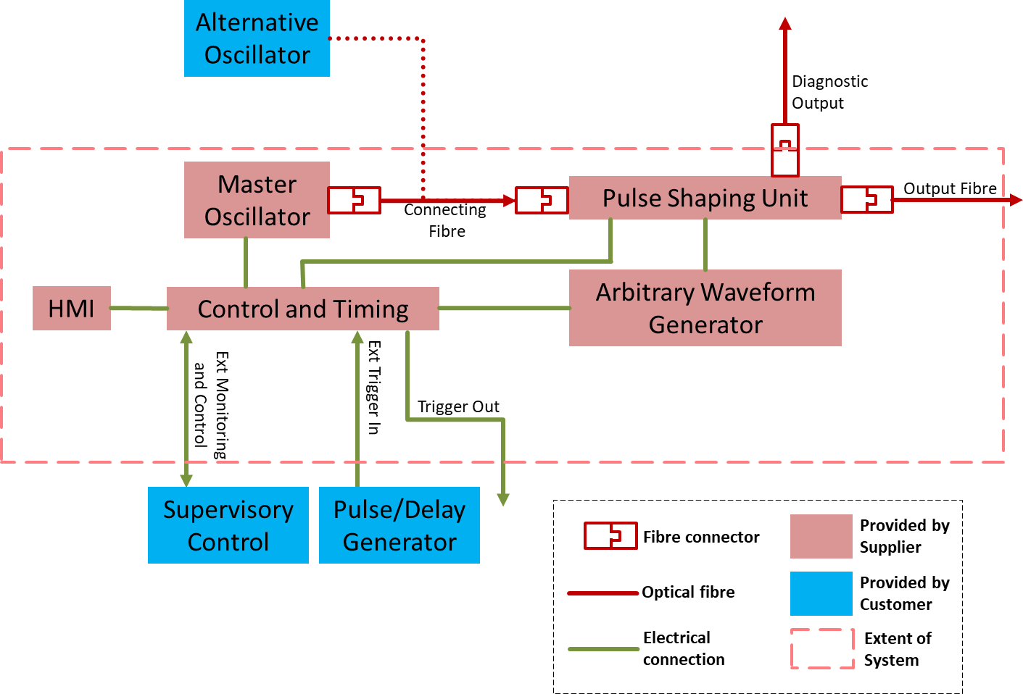
Figure 1: Block diagram of System. For details see text. HMI stands for human-machine interface
- For details concerning the alternative oscillator see Section 3.1.
- For detailed output requirements see Section 4.
- For details regarding the diagnostic output see Section 5.
- For details regarding local and external control, trigger in and outputs, and the HMI see Section 6.

Alternative Oscillator
As outlined in Figure 1, the supplied Master Oscillator shall be connected to the rest of the System through an externally accessible fibre. The system shall function with an alternative, customer supplied, oscillator; to facilitate this it shall be possible to disconnect the master oscillator fibre to connect the alternative, customer supplied oscillator. The alternative oscillator will have the following output properties:
- Temporal: cw
- Spectral: narrow-band or broadband, but always within ± 1 nm of λ_{o} (as defined in Section 4.1).
- Power: up to 20 mW, maximum power can be limited as directed by the Supplier.
- Delivery through single-mode PM980 fibre, with PER of around 20 dB, with polarisation axis as directed by the Supplier. For information on connectors see Section 8.

PERFORMANCE SPECIFICATION FOR FIBRE SEED SOURCE
The output of the System shall be delivered by optical fibre (for details see Section 4.5). Unless stated otherwise, performance of the System will be measured at the output of this fibre and compared against the criteria detailed below. This means that specifications, unless stated otherwise, apply to the optical output pulses, and not to the electrical RF pulses produced by the AWG.
It is encouraged that data, including measurements undertaken in the past and how they were obtained, are provided by bidders to show capability to meet the specification.
The performance shall be demonstrated using the single frequency Master Oscillator delivered by the Supplier.
As mentioned in Section 3.1, the System will be capable to work with an alternative, customer-supplied oscillator, the “handover” between seed sources must be demonstrated. The Customer will make this alternative oscillator available to the Supplier for testing.

Spectral properties
The spectral properties, determined by the Master Oscillator, shall be as follows.
- The centre wavelength λ_{o} shall be 1029.8 nm (measured in vacuum) equivalent to 1029.5 nm (measured in air).
- The wavelength shall be tuneable by at least ±0.5 nm around λ_{o}.
- The wavelength shall be adjustable by the operator, in increments of 10pm,
- The information about the Master Oscillator the supplier intends to use shall be provided as part of the bid, ideally backed up by evidence such as datasheets. This shall include information on:
  - Spectral width, which shall be no more than 20 MHz.
  - Side-mode suppression which shall be better than 30 dB.
  - Wavelength stability which shall be better than ±10 pm over 6 hours.

Temporal properties
- The pulse repetition rate shall be at 10 kHz.
- The temporal pulse duration shall be programmable between 1 to 20 ns.
- The temporal pulse shape shall be arbitrarily controllable with a temporal resolution (step size) of no more than 125 ps.
- The jitter between the externally supplied electrical trigger pulse and the optical output pulse shall be no more than 50 ps RMS. See also Section 6.3 regarding timing and triggering.
- The pulse rise/fall times (10-90%) shall be less than 100 ps.

Amplitude control
- The temporal extinction ratio shall be at least 30 dB, measured within a time window of ± 15 ns relative to the centre of the output pulse.
- The minimum temporal extinction ratio shall be met for Master Oscillator wavelengths in the range of λ_{o} ± 1.0 nm.
- The minimum temporal extinction ratio must be maintained without operator intervention for at least three months. At longer time intervals, when required, suitably trained operators must be able to make adjustments, using commonly available instrumentation and without having to open the housing of the System.
- The resolution with which the amplitude of the pulse can be controlled shall be at least 12 bit.
- For a square output pulse, ripples in the plateau region of the pulse, shall not exceed ± 1.5 % peak-to-peak of the pulse amplitude.

Energy, power and stability
- The maximum peak power shall be at least 500 mW, meaning the pulse energy for a square pulse will be at least 0.5 nJ at 1 ns duration, and 5 nJ at 10ns duration.
- The system will be used to seed a laser system operating at 100 Hz, therefore pulse-to-pulse energy stability shall be measured at that rate, i.e. by an instrument that is triggered at one-hundredth of the System’s internal repetition rate. The pulse-to-pulse energy stability for 100 % of pulses, measured in this way, over 1 minute (equal to 6000 pulses), will be better that ± 1 % peak-to-peak. The RMS stability (or standard deviation) within that time frame will be better than 1 %.
- The stability of average power will meet the criteria listed in the following. The method to measure the average power shall be agreed during the kick-off meeting.
  - The average power will be stable within ± 1 % peak-to-peak over a period of 15 min.
  - The average power will be stable within ± 2.0 % peak-to-peak over a period of 8 h, provided the ambient temperature does not vary by more than ± 1.0 °C.

Polarisation and output delivery
- The output shall be delivered through a detachable single-mode PM980 panda fibre. For connectors, length and sheathing see Section 8.
- The output shall be linearly polarised along the slow axis direction of the output fibre.
- The polarisation extinction ratio (PER) shall be better than 30 dB.
- Isolation will be placed following each amplifier stage and at the output to protect from optical feedback from subsequent stages.

Diagnostics
The seed source shall provide an additional optical output signal that it is optically split (at the few-% level) from the main output and that is made available through a fibre port, such that an external, SM-fibre coupled photodiode can be connected.

Electronics & Control

Local and supervisory control
The System shall contain its own local control and data acquisition system, including an HMI (human-machine interface, also called user interface), so the System can be controlled locally and operated stand-alone.
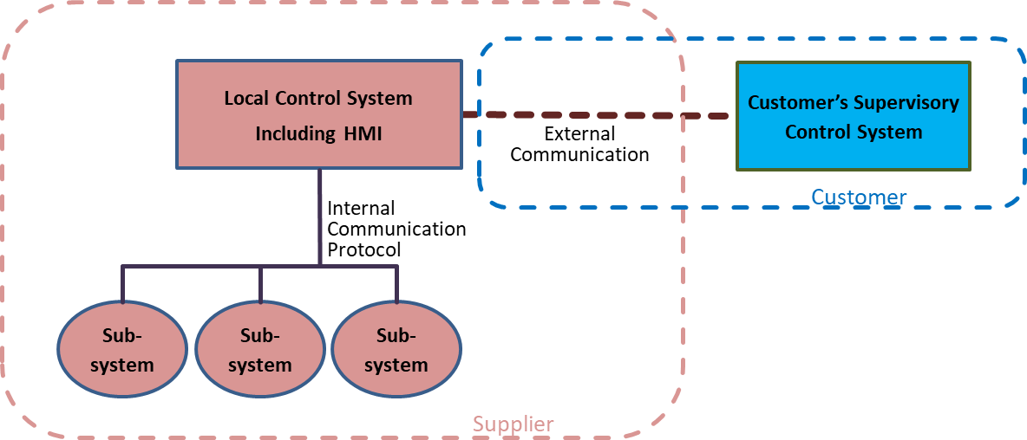
Figure 2: Illustration of control system architecture, indicating areas of responsibility of the Supplier, of the Customer, and where an interface needs to be agreed.

Once delivered, the System shall allow full integration into an overarching supervisory control system. The supervisory control system will be developed using EPICS (see https://epics.anl.gov/), an open-source distributed control system framework used in many large-scale science facilities, such as particle accelerators or synchrotron light sources.
To this end, the local control system shall provide an interface, for remote control and monitoring of the System, which is compatible with EPICS control over Ethernet, including EPICS drivers. Details of the Application Programming Interface (API) can be worked out collaboratively and iteratively with HiLASE.
‘Remote Desktop’ solutions such as VNC, or replicating the local HMI on a remote PC, are not acceptable as they do not provide the level of integration expected and required by supervising control system.
Providing remote access/control of the System directly (i.e. bypassing the local control system) and/or to low-level hardware communication software libraries is also not acceptable; the whole System must be seen as a black-box from the supervisory control system with at least the following functionality:
- The control functionality needs to include everything required for day-to-day operations of the System. Advanced functions that would only be used during set-up or maintenance of the System do not need to be made available to the supervisory control system.
- All data, including errors/faults/alarms that is acquired by the local control system should also be available for the supervisory control system.
- A “health signal” to indicate whether the System is OK or not.
- A command indicating what error was last produced.
- The ability to set the IP address for external communication

Functionality of local control system
The functionality of the local control system shall include at least the following:

Control and monitoring of basic functions
- Control of System operation (turning the System on and off).
- Control of the output power.
- Control of the wavelength.
- Displaying of basic set and, if available, actual values such as wavelength, Master Oscillator cw power, output peak power, alarms and faults (e.g. interlock fault, see also Section 7.1).
- Further requirements can be included and should be discussed with HiLASE.

Pulse shape control
- During operation, the System shall provide the capability to make adjustments to the active pulse shape, meaning that for individual samples of the AWG wave form (if possible also groups of samples) the signal level can be changed ‘on the fly’, such that this will not cause dropped pulses or significant fluctuations in the output energy, other than the energy change caused by the adjustment itself.
- The System shall further provide the capability to save pulse shapes to and load them back from non-volatile internal memory that can hold at least 100 different shapes.
The shapes shall be stored in a human-readable ASCII format and it shall be possible to download files from and upload them to the local control system, e.g. using a USB flash drive.
- It is acceptable for optical output pulses to be dropped while a new pulse shape is loaded, however, no optical output shall be generated which consist of only part of the new pulse shape.
- It is desirable for the local control system to provide a tool to create simple pulse shapes such as squares and triangles.

Triggering
The System will be triggered at the rate of 10 kHz from the customer’s external pulse/delay generator during normal operations. The trigger signal will be a TTL-type signal.
The System shall only require a single external trigger signal, required additional timing signals shall be generated internally.
An RF-clock signal (80 MHz sinusoidal signal) can also be provided by the customer if it is required to meet the jitter specification detailed in Section 4.2.

Safety & self-protection

Laser safety & interlock
The System shall comply with the European laser safety standard BS EN 60825 and shall be CE certified.
The System shall contain an interlock connector for personnel safety. Details will be specified during the design phase of the contract. The requirements will include the following:
- An interlock signals will be provided by HiLASE through a potential free contact which the System needs to constantly monitor using appropriate hardware qualified to the appropriate safety standards.
- The safety interlock system design must demonstrably (by means of fault tree or failure mode effects analysis) minimise the probability of failure to danger. This is achieved through the appropriate selection of certified components (such as self-monitoring safety relays, safety PLCs etc.). Details of the safety interlock system design with justification of component choices must be supplied to HiLASE to enable HiLASE to complete a full analysis of the safety system including HiLASE supplied components.

Self-protection
The System shall be tolerant to the following conditions and not suffer immediate damage or accelerated long-term degradation.
- The presence of optical feedback from external components, against which a reasonable degree of optical isolation shall be provided at the output.
- Sudden loss of Oscillator power and sudden activation of Oscillator, in particular if an alternative oscillator is used that is not integrated into the local control system. It is acceptable if the Pulse Shaping Unit shuts itself down if insufficient Oscillator input is detected and that it can only be restarted when Oscillator input is restored.
- Changes in external trigger rate, dropped trigger pulses or total loss of external trigger. Again, it is acceptable for the Pulse Shaping Unit to shut down in such circumstances.

Mechanical
- All components shall come in 19” rack mountable units. Separate units or a single integrated solution are both acceptable.
- The type of fibre connectors used within the system shall be agreed during the kick-off meeting, except the connector at the end of the output fibre which shall be FC/APC.
- The detachable output fibre will be in a protected sheath and > 10 m in length.

Electrical
- All modules requiring mains power shall have an IEC 60320, C14 inlet (commonly found on personal computers etc.)..
- The System shall be capable of withstanding a failure of the mains electrical supply without causing, or increasing the likelihood of, damage or deterioration of any electrical or optical component.

Quality Assurance and testing
The Supplier will provide the full contact details of its Quality Manager, or member of staff responsible for quality approval and processes no later than two weeks after the signing of the contract.
A quality plan will be generated by the Supplier and this documentation will be made available to the Customer. The Plan should be based around the ‘Bill of Materials’ for the complete deliverable which shows the detail concerning the inspection and testing criteria of each individual part. The plan must also indicate details concerning the documented processes and quality control records that will be used and made available to the Customer.
The Supplier will grant access to its work premises for the Customer to undertake periodic quality control inspections as required.
The Supplier shall notify the Customer of such events providing a minimum of 14 calendar days’ notice.

Documentation and manuals
The Supplier shall provide:
- Installation manuals, in English in reproducible form – in advance of delivery/after design review.
- Operating and Maintenance manuals, in English in reproducible form.
- Full documentation of the control system including details of the API with a list of the protocols and examples of their usage
- Copies of technical construction files used for CE marking to ensure compliance with relevant directives.
- A certificate of conformity to this specification, with procedures for this testing to be agreed.
- Agendas and minutes of kick off, technical meetings and design reviews/approvals.
- Factory Acceptance Test (FAT) and Site Acceptance Test (SAT) documents – templates at least 1 month ahead of testing.
- A list of suggested spare parts shall be provided including the lead time and cost of each part.

Warranty, lifetime and support
A three year warranty is required as a minimum.

Schedule, milestones, reviews
The maximum delivery schedule is till 31.10.2023 including Site Acceptance Test (SAT). A full breakdown of the delivery schedule will be provided within 1 month of award of contract.
The quality plan and schedule must be provided and accepted at the kick off meeting which will constitute a project milestone with an associated payment.
A Factory Acceptance Test (FAT) demonstrating conformity with this specification shall be carried out at the Suppliers factory. A test schedule will be proposed for agreement within three months of the contract being awarded.
A SAT of the system will be required following installation at the Buyer’s premises. This shall be a repeat of the FAT.
.
The Supplier shall bring their own equipment to demonstrate the system performance during the SAT. This equipment includes:
- Tools
- Instrumentation and ancillary equipment for testing, for example power meter, spectrometer etc.

