Confidentiality Level |  | BL - Restricted for internal use | TC ID / Revision |  | 003052 / B
Document Status |  | Draft | Document No. |  | 00106855 / C
WBS code |  | 4.1 - Alignment
PBS code |  | SE.BDS.ALGN.5.1
Requirements Specification Document (RSD)
Laser sources for alignment TP14_022


Keywords

Put keywords related to the document content.
 | Position |  |  | Name
Responsible person | Optical Engineer |  |  | Roberto Ziano
Prepared by | Optical Engineer  Technical Director |  |  | Roberto Ziano  Bruno Le Garrec

RSS TC ID/revision | Date of Creation | Date of Last Modification | Systems Engineer
003052 / A | 12/02/2015 | 13/02/2015 | Aleksei Kuzmenko
003052 / B | 16/02/2015 | 25/02/2015 | Aleksei Kuzmenko

Reviewed By
Name (Reviewer) | Position | Date | Signature


Approved by
Name (Approver) | Position | Date | Signature
Bruno Le Garrec | Technical Director | 25/2/2014 | 

Revision History / Change Log
Change No. | Made by | Date | Change description, Pages, Chapters | TC rev.

Table of Content

1. Introduction 4
1.1. Description of the product 4
1.2. Scope 4
1.3. Terms, Definitions and Abbreviations 4
1.4. Reference and applicable document 5
1.5. Description of Item 1 5
1.5.1. Expected internal set-up of short pulse duration alignment laser (Figure 1). 5
1.5.2. Expected internal set-up of short pulse duration with two identical and synchronized output beams (Figure 2). 6
2. Functional and Performance requirements 6
2.1. Laser Item 1 6
2.1.1. General system requirements 6
2.1.2. Output of System Level 7
2.1.3. Design Requirements 8
2.1.4. Control system requirements 9
2.1.5. Transportation and Installation requirements 10
2.2. Laser Item 2 10
2.2.1. Output of System Level 10
2.2.2. Design Requirements 11
2.2.3. Control system requirements 12
3. General Safety Requirements 12
4. Quality Requirements 12
4.1. Quality Management 12
4.1.1. Documentation and data control 12
4.1.2. Warranty Conditions 13
5. Verification Requirements 14
5.1. General requirements 14
5.2. Review 14
5.3. Inspection 14
5.4. Test 15
5.5. Functional Demonstration 15
5.6. Analysis 15
5.7. Verification Control Document (VCD) 16

Introduction

Description of the product

There are two different types of laser: the first one should provide short pulse duration at 1 kHz repetition rate at 800 nm wavelength and the second one is a classical low power Nd:YAG laser at 1064 nm. The devices will be used as alignment lasers and must be available and reliable for daily operation. Moreover, the first type of laser will be used for preparing experiments during the commissioning phase of the ELI facility and we need to be able to deliver two identical and synchronized beams.
The list of the expected items is as follows:
- One short pulse duration laser system at 1 kHz repetition rate at 800 nm able to delivering two identical and synchronized beams. This system will be used in ELI-Beamlines as alignment laser for L1 laser to E1 experimental hall.
- One classical low power Nd:YAG laser at 1064 nm. This system will be used in ELI-Beamlines as alignment laser for L4 laser to E3, E4 and E5 experimental halls.

Scope

This RSD contains all of the top level functional, performance, safety, operational, design and quality requirements of alignment laser for L1 and L4 lasers to E1, E3, E4 and E5 experimental halls.

Terms, Definitions and Abbreviations

For the purposes of this document, the terms and definitions from ECSS-S-ST-00-01 apply (AD -001). For the purpose of this document, the following abbreviated terms apply:

Abbreviation | Meaning
ELI | Extreme Light Infrastructure
RSD | Requirement Specification Document
E1, E2, E3, E4, E5 | Experimental area (hall) 1, 2, 3, 4, 5
mJ | Milli Joule (10⁻³)
nm | Nano meter (10⁻⁹)
fs | Femtosecond (10⁻¹⁵)
RMS | Root Mean Square
FWHM | Full Width at Half Maximum
L1 | Laser 1 (1 kHz, 100 mJ)
L3 | Laser 3 (10 Hz, 1 PW)
L4 | 10 PW kJ laser system
R | Review of Design
FD | Functional Demonstration
T | Test
I | Inspection
L x W x H | Length x width x height

Reference and applicable document

Applicable documents – ECSS standards (http://www.ecss.nl/)

Number of document | Title of document
AD-01 | ECSS-S-ST-00-01 Glossary of Terms
AD-02 | ECSS-E-ST-10-06C Technical Requirements Specification

Description of Item 1

The first type of laser ELI-Beamlines is going to purchase is foreseen as a closed box system containing four main subsystems: an oscillator, an amplifier pumped by a green pump laser and a compressor (as shown in Figure 1).

Expected internal set-up of short pulse duration alignment laser (Figure 1).

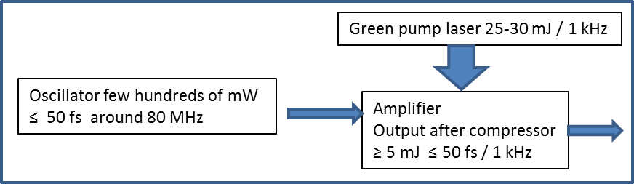
Figure 1: expected internal set-up of short pulse duration alignment laser.

For delivering two identical short pulse duration beams fully synchronized, it is expected to have two identical systems and that the oscillator of the first laser will be able to feed both the amplifier of the first laser and the amplifier of the second laser (as in Figure 2).

Expected internal set-up of short pulse duration with two identical and synchronized output beams (Figure 2).

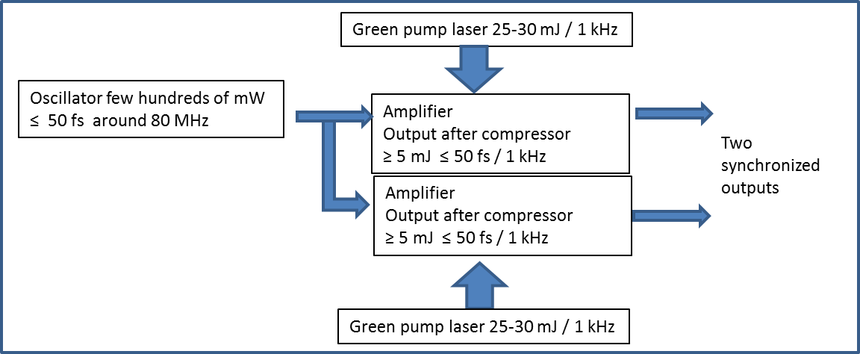
Figure 2: expected internal set-up of short pulse duration alignment laser with two identical and fully synchronized output beams.

Both figures are given as examples and only the output performance is part of the technical specification. All other values are not part of the technical specification.

Functional and Performance requirements

Laser Item 1

This system will be used in ELI-Beamlines as alignment laser for L1 laser to E1 experimental hall.
The laser of item 1 provides two identical and synchronized outputs.

General system requirements

The following part of requirements specification is for the laser system itself:

REQ-006265/A
The two laser outputs shall be synchronized.
Verification method: T - test

REQ-006266/A
Delay between the two laser outputs shall be up to 1 ms.
Verification method: T - test

REQ-006267/A
The two laser outputs shall be synchronized with better accuracy than 1% of the delay.
Verification method: T - test

Output of System Level

Each of the outputs should be as follows:

REQ-006248/A
The Central Wavelength shall be 805 ± 10 nm.
Verification method: T - test

REQ-006249/A
The average power shall be not less than 5 W.
Verification method: T - test

REQ-006250/A
Energy per Pulse shall be not less than 5 mJ.
Verification method: T - test

REQ-006251/A
Energy stability (RMS) for 24 hours shall be less than 1%.
Verification method: T - test

REQ-006252/A
Pulse duration (FWHM) shall be less than 50 fs.
Note: A Gaussian pulse shape (0.7 deconvolution factor) is used to determine pulse width (FWHM) from autocorrelation signal.
Verification method: T - test

REQ-006253/A
The pulse Bandwidth (FWHM) shall be not less than 20 nm.
Verification method: T - test

REQ-006254/A
The repetition rate shall be 1 KHz.
Verification method: T - test

REQ-006255/A
The laser system of item 1 polarization shall be Linear.
Verification method: T - test

REQ-006256/A
Spatial mode shall be TEM₀₀
Verification method: T - test

REQ-006257/A
Warm-up time shall be not more than 30 mn.
Verification method: T - test

REQ-006258/A
M² shall be less than 1.5
Verification method: T - test

REQ-006259/A
Beam diameter at 1/e² shall be less than 15 mm.
Verification method: T - test

REQ-006260/A
Pointing stability (RMS) shall be less than 2 µrad.
Note: RMS value measured under stable environmental conditions (laser technology areas and experimental areas: 20 ± 0.5 °C) after warm-up time and over one hour.
Verification method: T - test

REQ-006261/A
Synchronization of out signal shall be TTL or shall be more than +2 V over 50 Ω load.
Verification method: T - test

REQ-006262/A
Pre-pulse contrast shall be more than 1000:1
Note: Defined as the ratio between peak intensity of output pulse to peak intensity of any pre-pulse that occurs >1 ns before the output pulse
Verification method: T - test

REQ-006263/A
Post-pulse contrast shall be more than 100:1
Note: Defined as the ratio between peak intensity of output pulse to peak intensity of any post-pulse that occurs >1 ns after the output pulse.
Verification method: T - test

Design Requirements

General Design Requirements

REQ-006379/A
Breadboard thickness shall be 305 mm (12 inches).
Verification method: I - inspection

REQ-006270/A
System shall be covered.
Verification method: I - inspection
REQ-006377/A
The laser system shall have stainless steel optical table with internal tuned vibration damper and rigid support structure with passive vibration isolation.
Verification method: I - inspection

REQ-006269/A
The laser system shall be fitted on an optical table.
Verification method: I - inspection

REQ-006271/A
System shall be compliant for use in a clean room ISO 7.
Verification method: T - test

Dimensions

REQ-006268/A
Dimensions (w x l x h) shall not exceed 1500 x 2700 x 700 mm.
Verification method: R – review, I - inspection

Electrical requirements

REQ-006273/A
Total average power consumption including system cooling equipment shall be less than 10kW.
Verification method: T - test

REQ-006274/A
Power cord length between local power supplier and experimental hall power rack shall be not less than 10 m (min).
Verification method: I - inspection

REQ-006275/A
System shall be with European standard plug-in/socket for 230 V AC.
Verification method: I - inspection

Control system requirements

REQ-006264/A
Interface of ELI control system shall be with access to interlocks and system statuses.
Verification method: T - test

Transportation and Installation requirements

REQ-006272/A
The optical table shall be included in the delivery of the system.
Verification method: I - inspection

Laser Item 2

This system will be used in ELI-Beamlines as alignment laser for L4 laser to E3, E4 and E5 experimental halls.

Output of System Level

REQ-006300/A
Central Wavelength shall be 1064 nm.
Verification method: T - test

REQ-006301/A
Average power shall be not less than 1 W.
Verification method: T - test

REQ-006302/A
Pulse duration (FWHM) shall be not more than 50 ns.
Verification method: T - test

REQ-006303/A
The laser system of item 2 polarization shall be Linear.
Verification method: T - test

REQ-006304/A
Spatial mode shall be TEM₀₀
Verification method: T - test

REQ-006305/A
M² shall be less than 1.5.
Verification method: T - test

REQ-006306/A
Beam diameter at 1/e² shall be less than 15 mm.
Verification method: T - test

REQ-006307/A
Warm-up time shall be not more than 30 mn.
Verification method: T - test

REQ-006308/A
Pointing stability (RMS) shall be less than 2 µrad.
Note: RMS value measured under stable environmental conditions after warm-up time and over one hour.
Verification method: T - test

REQ-006309/A
Synchronization of out signal shall be TTL or shall be more than +2 V over 50 Ω load.
Verification method: T - test

Design Requirements

General Design Requirements

REQ-006313/A
System shall be covered
Verification method: I - inspection

REQ-006314/A
System shall be compliant for use in a clean room ISO 7
Verification method: T - test

Dimensions

REQ-006319/A
Dimensions (w x l x h) shall not exceed either 1000 x 1000 x 500 mm
Verification method: R – review, I - inspection

Electrical requirements

REQ-006315/A
Total average power consumption including system cooling equipment shall be less than 1kW.
Verification method: T - test

REQ-006316/A
Power cord length between local power supplier and experimental hall power rack shall be not less than 10 m (min).
Verification method: I - inspection

REQ-006317/A
System shall be with European standard plug-in/socket for 230 V AC.
Verification method: I - inspection

Control system requirements

REQ-006310/A
Interface of ELI control system shall be with access to interlocks and system statuses.
Verification method: T - test

General Safety Requirements

REQ-006893/A
System or its relevant components shall comply with all applicable EU and Czech legislative requirements and where applicable shall have CE marking and Certificate of Compliance.
Verification method: R - review

REQ-006894/A
Supplier shall perform hazard identification and risk assessment of system prior to design.
Verification method: R - review

REQ-006895/A
System shall be delivered with operational manual and technical documentation where supplied specifies modes of operation, conditions for safe operation, and maintenance of system.
Verification method: R - review

Quality Requirements

Quality Management

Documentation and data control

Documentation

REQ-007089/A
The supplier shall supply the following relevant documents (extent as stipulated in contract): Operating manual, maintenance manual, breakdown list as built, Declarations of Conformity and relevant CE markings where required by EU legislation.
Verification method: R - review

REQ-007090/A
The supplier shall supply certificate of compliance of furnished pieces with design and manufacturing documentation.
Verification method: R - review

REQ-007096/A
This certificate of compliance shall be compatible with EN ISO/IEC 17050-1 and EN ISO/IEC 17050-2.
Verification method: R - review

Formats for data exchange

REQ-007091/A
Documentation shall be supplied in all following formats: hardcopy and PDF/A.
Verification method: I - inspection

REQ-007092/A
The supplier shall provide following type of documents:
- 3D model (if available)
- 2D drawings
- Printable format for text documents
Verification method: I - inspection

REQ-007093/A
The Supplier shall use following data formats.
- *.JPG
- *.PDF/A
- CAD 2D: *.dwg
- CAD 3D: STEP type files (*.stp;*.ste;*.step)
- text processors *.doc, *.docx, OpenDocument Format
- spreadsheet processors *.xls, *.xlsx, OpenDocument Format
- presentations *.ppt, *.pptx; OpenDocument Format
- *.HTML

Verification method: I - inspection

Warranty Conditions

REQ-007095/A
Supplier shall include applicable warranty and support policies as part of the response to the tender.
Verification method: R - review

Verification Requirements

General requirements

REQ-006954/A
Verification process (acceptance) of deliverables shall be performed according to contract statements defined in corresponding chapter (verification/acceptance).
Verification method: R - review

Review

Verification by Review (R) shall consist in using approved records or evidence that unambiguously shows that the requirement is met.

NOTE Examples of such approved records are design documents and reports, technical descriptions, and engineering drawings, manuals and accompanying operation documentation.

REQ-006955/A
The list of accomplished requirements and the list of unaccomplished and incomplete requirements shall be made.
Verification method: R - review

REQ-006956/A
The results of review shall be documented in approved record.
Verification method: R - review

Inspection

Verification by Inspection (I) shall consist of visual determination of physical characteristics.

NOTE Physical characteristics include constructional features, hardware conformance to document drawing or workmanship requirements, physical conditions, software source code conformance with coding standards.

REQ-006957/A
The list of accomplished requirements and their physical location and presence, and the list of unaccomplished and incomplete requirements shall be made.
Verification method: R - review

REQ-006958/A
The results of inspection shall be documented in approved record.
Verification method: R - review

Test

Verification via Test (T) shall be performed to test a measurable parameter.

REQ-006959/A
The protocol of the measurement shall be made and approved.
Verification method: R - review

REQ-006960/A
The list of accomplished requirements with the note of measured value and the list of unaccomplished and incomplete requirement shall be made.
Verification method: R - review

REQ-006961/A
The test plan shall be defined including all requirements where is applied test as the verification method.
Verification method: R - review

REQ-006962/A
Test plan shall be approved by the Customer.
Verification method: R - review

Functional Demonstration

Verification via Functional demonstration (FD) shall be performed to test the system’s response to a subject of requirement and check if its response is within the limits of the requirement.

REQ-006963/A
Verification programme by Functional demonstration shall be a part of the Test Plan (see chapter Test).
Verification method: R - review

REQ-006964/A
The protocol of functional demonstration shall be made and approved.
Verification method: R - review

REQ-006965/A
The list of accomplished requirements and the list of unaccomplished and incomplete requirements shall be made.
Verification method: R - review

Analysis

REQ-006966/A
Verification by analysis shall consist of performing theoretical or empirical evaluation using techniques agreed with the Customer.
NOTE Techniques comprise systematic, statistical and qualitative design analysis, modelling and computational simulation.
Verification method: R - review

REQ-006967/A
Verification by similarity shall be part of the verification by analysis.
Verification method: R - review

REQ-006968/A
Similarity analysis shall define differences that can dictate complementary verification activities.
Verification method: R - review

Verification Control Document (VCD)

The Verification Control Document lists the requirements to be verified with the use of selected methods at the defined levels. The VCD is a living document and provides traceability during the phases of a contract realization how and when each requirement is planned to be verified and is actually verified.

REQ-006969/A
The content of the completed Verification Control Document (VCD) shall be agreed by the Customer and the Supplier.
Verification method: R - review

REQ-006970/A
The final issue of the Verification Control Document (VCD) shall be submitted to the Verification Control Board (Acceptance Board) after the approval of the last report, within the time frame agreed with the customer.

Verification method: R - review

