Confidentiality Level |  | BL - Restricted for internal use | TC ID / Revision | 00116338 / C
Document Status |  | Document Released | Document No. | N/A
WBS code |  | 5.0 - Experimental Programmes
PBS code |  | E.E2 - E2 (RA2), E.E5.HELL - (RP3) High Energy Electron Beamline, E.E4.ELMA - (RA3) ELIMAIA (ELIMED + ION acceleration), RA1.L1.L1_1 - L1.1 beamline, RA1.L4.1 - L4 laser system
Requirements Specification Document (RSD)
Optical tables TP15_084



Keywords

N/A

 | Position |  |  |  | Name
Responsible person
Prepared by

Table of Content

1. Introduction 3
1.1. Purpose 3
1.2. Scope 3
1.3. Terms, Definitions and Abbreviations 3
2. Optical tables SET1 requirements 4
2.1. General requirements 4
3. Optical tables SET2 and breadboards SET3 requirements 5
3.1. SET2 General Requirements 5
3.2. SET3 General Requirements 6
4. Optical tables SET4 requirements 7
4.1. General requirements 7
5. Optical tables SET5 requirements 8
5.1. General requirements 8
6. Optical tables SET6 requirements 9
6.1. General requirements 9
7. Performance requirements 10
7.1. General requirements 10
7.2. Specific requirements 12
8. Operational requirements 13
8.1. General requirements 13
8.2. Documentation 13
9. Building and Environmental conditions 13
10. Handling, Storage, Maintenance and Manipulation requirements 13
11. Transportation and Installation requirements 14
11.1. General requirements 14
12. General Safety Requirements 15
13. Quality Requirements 15
13.1. Product Specific Quality Requirements 15
13.1.1. Documentation 15

Introduction

The Contracting authority is undertaking the ELI project with the objective of building a facility using cutting-edge laser technologies and to implement research and application projects in the field of laser-matter interaction using ultra-short laser pulses at high repetition rates and/or with high energy. Part of the project realization is the purchase and development of high stability optical tables and breadboards.

Purpose

This Requirements Specification Document (RSD) lists the technical requirements and constraints on optical tables applying on ELI project. This RSD also acts as the parent document for the technical requirements that need to be addressed in lower level design description documents.

Scope

This RSD contains all of the top level functional, performance, operational, safety and quality requirements for the tender TP15_084 “Optical tables”. These optical tables and breadboards shall be used in premises of ELI building for RA3 (“SET1”), RA2 (“SET2” and “SET3”) programmes, for the pump lasers of L1 Beamline (“SET4”) and development of L4 diagnostic systems (“SET5”) and LUX Beamline (“SET6”).

Terms, Definitions and Abbreviations

For the purpose of this document, the following abbreviated terms apply:

Abbreviation | Meaning
ELI | Extreme Light Infrastructure
L1,4 | Laser Hall 1, 4
OTS1,2,3 | Optical Tables Set 1, 2, 3
BBS1,2,3 | Breadboards Set 1, 2, 3
RSD | Requirement Specification Document
RA2,3 | Research Activity 2, 3

Optical tables SET1 requirements

General requirements

REQ-009851/A
The optical tables SET1 (further OTS1) shall consist of two pairs of identical tables as depicted in Figure 1.

REQ-009852/A
The dimensions of tabletop (OTS1) shall correspond to the length and width defined in the Figure 1.
NOTE: The dimensions of tabletop (OTS1) length and width can differ from parameters shown in Figure 1 not more than ± 50 mm.

REQ-009853/A
Minimum tabletop thickness of OTS1 shall be 150 mm.

REQ-009854/A
Static deflection of OTS1 shall be not more than 5x10⁻⁵ mm/N.

REQ-009855/A
Dynamic deflection above 100 Hz (compliance) of OTS1 shall be not more than 5x10⁻⁴ mm/N.

REQ-009856/A
Nominal height of tabletop (OTS1) above floor level shall be 900 mm.

Sketch of optical tables SET1 (Figure 1)
Figure 1: The length and width of optical tables SET1.

Optical tables SET2 and breadboards SET3 requirements

SET2 General Requirements

REQ-009872/A
The optical table SET2 (further OTS2) shall consist of one table as depicted in Figure 2.

REQ-009873/A
The dimensions of tabletop (OTS2) shall correspond to the length and width defined in the Figure 2.
NOTE: The dimensions of tabletop (OTS2) length and width can differ from parameters shown in Figure 2 not more than ± 50 mm.

REQ-009874/A
Minimum tabletop thickness of OTS2 shall be 300 mm.

REQ-009875/A
Static deflection of OTS2 shall be not more than 5x10⁻⁵ mm/N.

REQ-009876/A
Dynamic deflection above 100 Hz (compliance) of OTS2 shall be not more than 5x10⁻⁴ mm/N.

REQ-009877/A
Nominal height of tabletop (OTS2) above floor level shall be 1000 mm.

Sketch of optical tables SET2 (Figure 2)

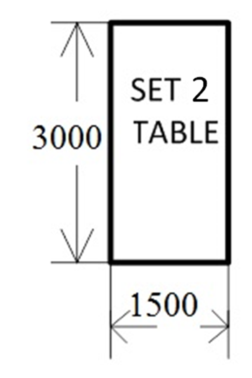
Figure 2: The length and width of optical tables SET2.

SET3 General Requirements

REQ-009878/A
The breadboards SET3 (further BBS3) shall consist of four identical breadboards with support frame as depicted in Figure 3.

REQ-009879/A
The dimensions of tabletop (BBS3) shall correspond to the length and width defined in the Figure 3.
NOTE: The dimensions of tabletop (BBS3) width and length can differ from parameters shown in Figure 3 not more than ± 50 mm.

REQ-009880/A
Minimum tabletop thickness of BBS3 shall be 110 mm.

REQ-009881/A
Static deflection of BBS3 shall be not more than 5x10⁻⁵ mm/N.

REQ-009882/A
Dynamic deflection above 100 Hz (compliance) of BBS3 shall be not more than 5x10⁻⁴ mm/N.

REQ-009883/A
Nominal height of tabletop (BBS3) above floor level shall be 1000 mm.

Sketch of breadboards SET3 (Figure 3)

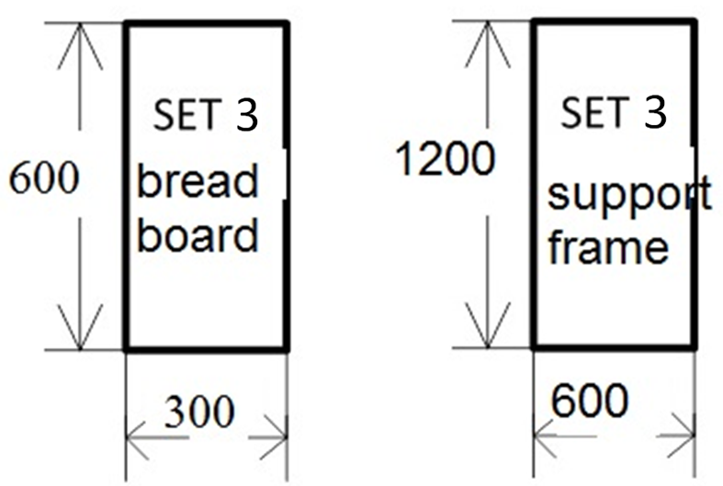
Figure 3: The length and width of breadboards SET3.

Optical tables SET4 requirements

General requirements

REQ-009899/A
The optical tables SET4 (further OTS4) shall consist of two identical separate tables as depicted in Figure 4.

REQ-009900/A
The dimensions of tabletop (OTS4) shall correspond to the length and width defined in the Figure 4.
NOTE: The dimensions of tabletop (OTS4) length and width can differ from parameters shown in Figure 4 not more than ± 50 mm (provided that tables L1/A and L1/B are identical).

REQ-009901/A
Minimum tabletop thickness of OTS4 shall be 300 mm.

REQ-009902/A
Static deflection of OTS4 shall be not more than 1x10⁻⁵ mm/N.

REQ-009903/A
Dynamic deflection above 100 Hz (compliance) of OTS4 shall be not more than 1x10⁻⁴ mm/N.

REQ-009904/A
Nominal height of tabletop (OTS4) above floor level shall be 1000 mm.

Sketch of two identical optical tables SET4 (Figure 4)

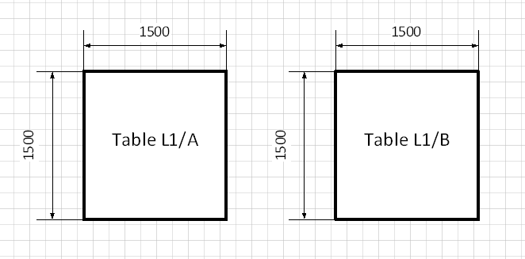
Figure 4: The length and width of optical tables SET4.

Optical tables SET5 requirements

General requirements

REQ-009920/A
The optical tables SET5 (further OTS5) shall consist of two identical tables as depicted in Figure 5.

REQ-009921/A
The dimensions of tabletop (OTS5) shall correspond to the length and width defined in the Figure 5.
NOTE: The dimensions of tabletop (OTS5) length and width can differ from parameters shown in Figure 5 not more than ± 50 mm (provided that width of all two tables is identical).

REQ-009922/A
Minimum tabletop thickness of OTS5 shall be 300 mm.

REQ-009923/A
Static deflection of OTS5 shall be not more than 2x10⁻⁵ mm/N.

REQ-009924/A
Dynamic deflection above 100 Hz (compliance) of OTS5 shall be not more than 2x10⁻⁴ mm/N.

REQ-009925/A
Nominal height of tabletop (OTS5) above floor level shall be 930 mm.
NOTE: This nominal height of tabletop will be accepted in a range of 880-980 mm.

Sketch of optical tables SET5 (Figure 5)

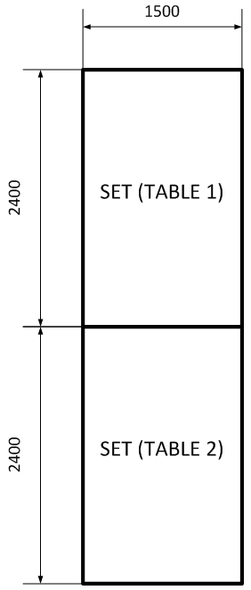
Figure 5: The length and width of optical tables SET5.

Optical tables SET6 requirements

General requirements

REQ-009980/A
The optical tables SET6 (further OTS6) shall consist of six tables as depicted in Figure 6.

REQ-009981/A
The dimensions of tabletop (OTS6) shall correspond to the length and width defined in the Figure 6.
NOTE: The dimensions of tabletop (OTS6) length and width can differ from parameters shown in Figure 6 not more than ± 50 mm.

REQ-009982/A
Minimum tabletop thickness of OTS6 shall be 150 mm.

REQ-009983/A
Static deflection of OTS6 shall be not more than 5x10⁻⁵ mm/N.

REQ-009984/A
Dynamic deflection above 100 Hz (compliance) of OTS6 shall be not more than 5x10⁻⁴ mm/N.

REQ-009985/A
Nominal height of tabletop (OTS6) above floor level shall be 900 mm.

Sketch of optical tables SET6 (Figure 6)

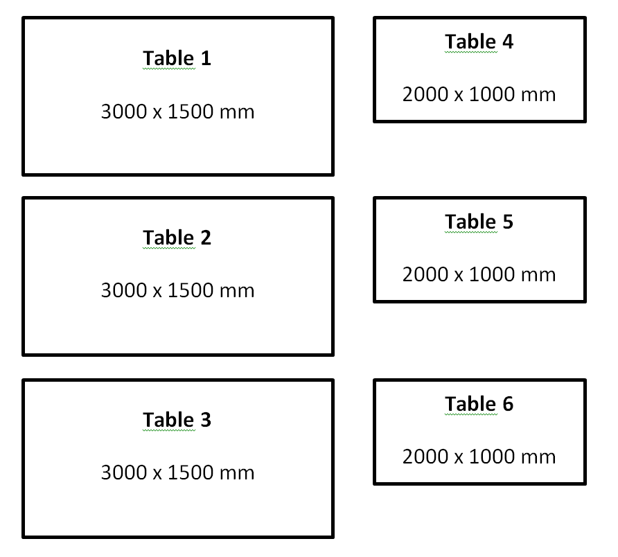
Figure 6: The length and width of optical tables SET6.

Performance requirements

General requirements

REQ-009986/A
The Vibration isolator supports for all optical tables and breadboards shall be supplied with each set of tables.

REQ-009857/A
The Vibration isolator supports of all optical tables and breadboards sets shall have rigid structure without active or passive vibration isolation.

REQ-009858/A
Vibration isolator supports shall have levelling capability allowing height adjustment of all optical tables and breadboards within at least 25 mm range with lock function.

REQ-009860/A
The top and bottom surface plates of tabletops of all optical tables and breadboards shall be made of ferromagnetic stainless steel (brushed including non-glare finish with coordinates on the sides of the top plate).

REQ-009861/A
The thickness of top and bottom surface plates of tabletops of all optical tables and breadboards shall be not less than 4.5 mm.

REQ-009862/A
The internal construction of tabletops of all optical tables and breadboards shall have honeycomb structure with internal cell size not exceeding 5 cm².

REQ-009863/A
The top surface of all optical tables and breadboards shall have grid of mounting holes.

REQ-009933/A
Mounting holes on the top surface of all optical tables and breadboards shall meet the following criteria:
- Tapped M6 holes;
- Min. 4.5 mm depth;
- Sealed.

REQ-009865/A
Grid of mounting holes on the top surface of all optical tables and breadboards shall have rectangular shape with 25 mm separation between centres of tapped holes.

REQ-009866/A
Grid of mounting holes on the top surface of all optical tables and breadboards shall cover and extend the whole table top surface except table edges.

REQ-009867/A
The mounting holes on the top surface of all optical tables and breadboards shall be located not further than 30 mm from table edge.

REQ-009868/A
Depth of mounting holes’ threads on the top surface of all optical tables and breadboards shall be not less than 15 mm.

REQ-009869/A
Maximum deviation from tabletop flatness of all optical tables and breadboards over any area of 1 m² shall be ± 0.15 mm.
REQ-009870/A
Minimum permitted load on any area of 1 m² of all optical tables and breadboards shall be 200 kg.

REQ-009871/A
First resonance frequency of the tabletop of all optical tables and breadboards shall be not less than 100 Hz.

Specific requirements

REQ-009886/A
All tabletops of OTS1, OTS2 and BBS3 shall include anti-vibration system with the following properties:
- Proprietary constrained layer damping for attenuating broadband vibrations;
- Thermalized design for Excellent Thermal Stability.

REQ-009907/A
All tabletops of OTS4, OTS5 and OTS6 shall include anti-vibration system with internal vibration damping (tuned damper).

REQ-009936/A
Grid of mounting holes (OTS5) coverage over table connection(s) shall be manufactured with max. distance between interrupted grids of 80 mm.

REQ-009942/A
The connection of OTS5 shall not be permanent and allow the tables of the set to be used separately.

REQ-009943/A
The connection of OTS5 shall not include any parts that protrude above the top surface.

REQ-009944/A
The connection of OTS5 shall be such as to guarantee that the whole assembled joined table maintains as one unit the required parameters in terms of flatness, dynamic and static parameters.

Operational requirements

General requirements

REQ-010194/A
The optical tables and breadboards shall be chemical stable against ethanol, Isopropyl alcohol and demineralised water which will be used during the cleaning procedures.

Documentation

REQ-009947/A
The supplier shall verify all performance requirements for each set of optical tables by supplier's factory verification procedures (e.g., outgoing inspections and tests) and provide to Contracting Authority corresponding verification records (protocols, reports).

REQ-009948/A
Each set shall be supplied with a dimensioned drawing showing the recommended positions of the table supports.

Building and Environmental conditions

REQ-009949/A
The optical tables and breadboards shall fulfil criteria for cleanrooms up to class 7 of the ČS EN ISO 14644 norm and maintain the required parameters in an environment stabilized to a set temperature within ±0.5 deg. C.

Handling, Storage, Maintenance and Manipulation requirements

REQ-009951/A
Each set shall be supplied with description of proper handling, storage, maintenance and transport procedures.

Transportation and Installation requirements

General requirements

REQ-009959/A
The transportation and installation personnel shall follow the Contracting Authority's facility regulations.
NOTE: These regulations shall be defined by the Contracting Authority and provided to the supplier before delivery.

REQ-009960/A
The technologies and instruments shall be delivered in protective package preventing damage and contamination and a minimum of two plies separate clean packaging. The technologies shall be cleaned and packaged in clean environment of Class 7 of the ČS EN ISO 14644 norm.
NOTE: The optical tables and breadboards shall be supplied cleaned and free from oils on surfaces (e.g. residues of cutting oils).

REQ-009962/A
All transportation and installation tools and equipment entering the clean rooms shall be cleaned and reviewed by the Contracting Authority's approved methods.
NOTE: Some tools can be provided by the Contracting Authority upon agreement.

REQ-009963/A
The transportation to the final destination and the installation of the technologies and the instruments shall be conducted by the supplier.

REQ-009964/A
The transportation and Installation procedures shall be discussed and reviewed by the Contracting Authority's installation officer and shall be compliant with the Contracting Authority's installation regulations.
NOTE: These regulations shall be defined by the Contracting Authority and provided to the supplier before delivery.

REQ-009966/A
Every person, who enters the ELI area shall attend a lecture about rules and procedures, which are related to the areas where they will be.
NOTE: This is especially aimed at safety, cleanliness, protection of the environment and working methods.

REQ-009967/A
The supplier shall allow supervising the activities related to the transportation and installation by the Contracting Authority.
NOTE: Any acts of supervision shall not mean that the Contracting Authority assumes additional liability of any kind exceeding its liabilities according to the contract.
REQ-009968/A
The clothing used at the installations shall conform to international standards (ČS EN ISO 14644) of cleanliness and the standards of the clean room (Class 7), in which the installation is carried out, in order to avoid contamination of the room and the equipment room.

REQ-009969/A
The supplier shall ensure that the installation of devices will be performed without contaminating the place of installation unnecessarily.

REQ-009970/A
The Supplier and Contracting Authority shall agree on the cleaning method to clean tools and equipment used at the installation without decreasing their performance or safety.

General Safety Requirements

REQ-009971/A
System or its relevant components shall comply with all applicable EU and Czech legislative requirements and where applicable shall have CE marking and Declaration of Conformity (see REQ-009976/A).

Quality Requirements

Product Specific Quality Requirements

Documentation

REQ-009974/A
The supplier shall provide to each set of optical tables User Manual involving description of transport, handling, storage, installation, and safe operation procedures.

REQ-009976/A
The supplier shall supply Declaration of Conformity for each product type. The declaration shall include following information:
- the name and address of the organisation taking responsibility for the product;
- a short description of the product;
- list which product safety Directives it complies with;
- may include details of relevant standards used for the product manufacturing and testing;
- and be dated, and signed by a representative of the organisation producing the product.

