annex 1.a
cover sheet of the bid (BID SHEET)
Public procurement title: „ Design and manufacture of FSYNC CMC Optomechanical table and CMC Optical Table Assy”

Part 1: Design and manufacture of FSYNC CMC Optomechanical table
Contracting Authority: Fyzikální ústav AV ČR, v.v.i.
Registered office: Na Slovance 2, 182 21 Praha 8
Registration No.: 68378271
Person authorized to act
on behalf of the bidder: RNDr. Michael Prouza, Ph.D., director
Contact person: David Pokorný
Telephone: 00420 601 555 056
E-mail: david.pokorny@eli-beams.eu
Bidder: ………………………………………………………………
Registered office: ………………………………………………………………
Identification No.: ………………………………………………………………
Person authorized to act
on behalf of the bidder: ………………………………………………………………
Contact person: ………………………………………………………………
Contact address: ………………………………………………………………
Telephone and e-mail: ………………………………………………………………
Total bid price (CZK net of VAT): …………………………………………………………
The bidder agrees to the mandatory technical and commercial requirements and conditions of the Contracting Authority.

The bidder is the payer of VAT: Yes/No*
*Cross out, which is not applicable
In _________________ on________________
______________________________
Company name
Authorised representative

annex 1.B
cover sheet of the bid (BID SHEET)
Public procurement title: „ Design and manufacture of FSYNC CMC Optomechanical table and CMC Optical Table Assy”

Part 2: Design and manufacture of FSYNC CMC Optical Table Assy
Contracting Authority: Fyzikální ústav AV ČR, v.v.i.
Registered office: Na Slovance 2, 182 21 Praha 8
Registration No.: 68378271
Person authorized to act
on behalf of the bidder: RNDr. Michael Prouza, Ph.D., director
Contact person: David Pokorný
Telephone: 00420 601 555 056
E-mail: david.pokorny@eli-beams.eu
Bidder: ………………………………………………………………
Registered office: ………………………………………………………………
Identification No.: ………………………………………………………………
Person authorized to act
on behalf of the bidder: ………………………………………………………………
Contact person: ………………………………………………………………
Contact address: ………………………………………………………………
Telephone and e-mail: ………………………………………………………………
Total bid price (CZK net of VAT): …………………………………………………………
The bidder agrees to the mandatory technical and commercial requirements and conditions of the Contracting Authority.

The bidder is the payer of VAT: Yes/No*
*Cross out, which is not applicable
In _________________ on________________ ______________________________
Company name
Authorised representative

annex 2.a
TECHNICAL SPECIFICATION (drawings list)
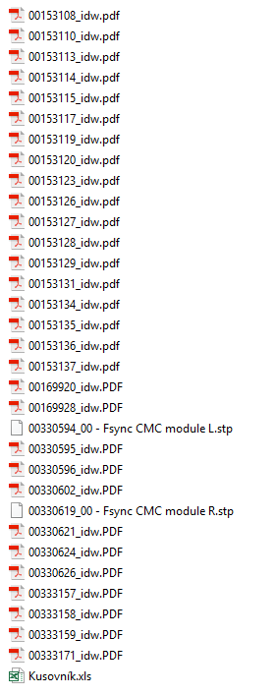

annex 2.b
TECHNICAL SPECIFICATION (drawings list)
