Confidentiality Level |  | BL - Restricted for internal use | TC ID / Revision |  | 00260975/D
Document Status |  | Document Released | Document No. |  | N/A
WBS code |  | 5.4 - RP5 – Laser plasma and high-energy-density physics
PBS code |  | E.E3.AUX.4.SPHM.1
Project branch |  | Engineering & Scientific documents (E&S)
Document Type |  | Specification (SP)
[RSD Product Category C]

High quality, large size spare Spherical mirror for Long focal length setup in E3
SP20_002

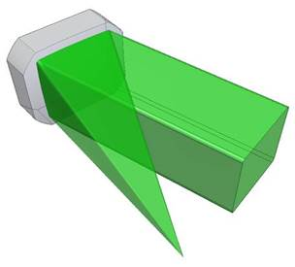

Keywords
Spherical mirror, parameters, requirements, beam transport and focusing

 | Position |  |  | Name
Responsible person | Post-Doctoral Researcher |  |  | Uddhab Chaulagain
Prepared by | Post-Doctoral Researcher |  |  | Uddhab Chaulagain

RSS History
RSS TC ID/revision | RSS - Date of Creation | RSS - Date of Last Modification | Systems Engineer
020260/A.001 | 21.02.2020 | 21.02.2020 | Aleksei Kuzmenko
020260/A.002 | 28.02.2020 | 28.02.2020 | Aleksei Kuzmenko
020260/A.003 | 06.03.2020 | 06.03.2020 | Aleksei Kuzmenko
020260/A.004 | 14.04.2020 | 14.04.2020 | Aleksei Kuzmenko
Reviewed By
Name (reviewer) | Position (reviewer) | Date | Signature (approver)
Deepak Kumar | Senior Researcher | NOTICE
Jaroslav Nejdl | RP2 Leader | NOTICE
Ladislav Půst | Manager installation of technology | NOTICE
Martin Laub | Chief Engineer
Roman Kuřátko | Facility Manager | NOTICE
Stefan A. Weber | RP5/6 Group leader
Veronika Olšovcová | Safety Coordinator
Viktor Fedosov | SE & Planning group leader;  Quality Manager


Approved by
Name (approver) | Position (approver) | Date | Signature (approver)
Georg Korn | Science and Technology Manager, Scientific coordinator of RP2-6

Revision History
Revision Number | Revision Made by | Date of Revision | Revision description | TC Revision
1. | U. Chaulagain | 19.02.2020 | RSD draft creation | A
2. | U. Chaulagain,  A. Kuzmenko | 28.02.2020 | RSD version intended for internal review | B
3. | A. Kuzmenko | 06.03.2020 | RSD update based on the results of the 1st review process | C
4. | A. Kuzmenko,  U. Chaulagain | 14.04.2020 | RSD update based on the results of the 2nd review process, final version for approval | D

Table of Content

1. Introduction 4
1.1. Purpose 4
1.2. Scope 4
1.3. Terms, Definitions and Abbreviations 4
1.4. Reference documents 5
1.5. References to standards 5
2. General requirement 5
3. Functional, Performance and Design requirements 6
3.1. Geometry and Substrate 6
3.2. SP mirror coating 6
3.3. SP mirror surface 7
3.4. Other SP requirements 8
4. Environmental requirements 11
5. Delivery requirements 11
6. Safety Requirements 12
7. Quality control 12
7.1. Quality Reports (QRs) 12
7.2. Documentation and data control 13
7.3. Nonconformity Control System 14
7.4. Verification requirements for the Supplier 14
7.4.1. Verification methods 14
7.4.2. Verification Control Document (VCD) 14
7.5. Phasing of the delivery 15
7.5.1. Qualification of Design 15
7.5.2. Manufacturing 16
7.5.3. Acceptance 17

Introduction

Purpose

This Requirements Specification Document (RSD) lists the technical requirements and constraints of the L3 target parabola for the high-intensity electron acceleration and X-ray pulse generation at the ELI Beamlines project. This can lead to the identification of product interface with the ELI science-based technology and ELI building facility. This RSD also acts as a parent document for technical requirements that need to be addressed in lower level design description documents.

Scope

This RSD contains all of the technical requirements: functional, performance and design, delivery, safety and quality requirements for the following product (tender number - SP20_002): High quality, large size focusing Spherical mirror (further “Spherical mirror” or “SP mirror”).

The Spherical mirror is integral part of the “E3 Plasma Physics Platform” system and will be placed in the E3 experimental hall. This mirror is registered in the PBS software under the following PBS code: E.E3.AUX.4.SPHM.1.

Terms, Definitions and Abbreviations

For the purpose of this document, the following abbreviated terms are applied:

Abbreviation | Meaning
A | Analysis (as a verification method)
CA | Contracting Authority (Institute of Physics AV CR, v. v. i.)
CAP | Clear Aperture
E2 | Experimental hall 2
ELI | Extreme Light Infrastructure
GDD | Group Delay Dispersion
I | Inspection (as a verification method)
L3 | Laser 3
LWFA | Laser Wakefield Accelerator
NCR | Nonconformity Report
pc | Piece
PD | Physical Dimension
R | Review of documentation (as a verification method)
RA5 | Research Activity 5
RH | Relative Humidity
RMS | Root Mean Square
ROC | Radius of Curvature
RSD | Requirements Specification Document
SP | Spherical mirror
T | Test (as a verification method)
ULE | Ultra Low Expansion glass
VCD | Verification Control Document

Reference documents

Number of doc. | Title of Document/File
RD-01 | 00169847-01_DRW_SPmirror-Substrate5mFocus_SP20_002.pdf
RD-02 | 00261003-A_VCD_Llarge size spare Spherical mirror for Long focal length setup_SP20_002.xlsx

References to standards

If this document includes references to standards or standardized/ standardizing technical documents the CA allows/permits also another equal solution to be offered. If a supplier offers another equal solution the CA shall not reject its bid, once the supplier by appropriate means in the bid proves that the offered supplies, services or works meet in an equivalent manner the requirements including references to standards or technical documents.

General requirement

The requested Spherical mirror will be used as a final focusing element of a 1 PW-class laser beam in high intensity experiments for X-ray production in LWFA scheme in E3 experimental hall.

REQ-028617/A
The Supplier shall deliver 1 pc of the Spherical mirror in accordance with requirements described in the subchapter 3.
Verification method: I – inspection

Functional, Performance and Design requirements

Geometry and Substrate

REQ-028618/A
The substrate material of the SP mirror shall be manufactured from mirror grade ULE, Zerodur, fused silica, high-power laser compatible or equivalent quality material.
Verification method: R - review (Substrate material report or certificate)
REQ-028619/A
The SP mirror (along the beam) shall be rectangular in shape with physical dimension of (310+0-1) x (270+0-1) mm².
NOTE: The dimensions shall correspond to the requirements given in the reference drawing RD-01 (see chapter 1.4) which is an inseparable part of the SP mirror requirements.
Verification method: R - review, T - test (Dimensional report)
REQ-028620/A
The clear aperture of the SP mirror (along the beam) shall be squared (center of the clear aperture is the mirror center). The clear aperture shall be squared with dimensions at least 250x250 mm² and with rounded corners.
Verification method: R - review, T – test
REQ-028621/A
The center thickness of the SP mirror shall be (60±1) mm.
Verification method: R - review, T - test (Dimensional report)
REQ-028622/A
The radius of curvature (center of the SP mirror to the focal point) shall be (10000±20) mm.
Verification method: R – review, T - test

SP mirror coating

REQ-028625/A
The front (i.e. reflective) surface of the SP mirror shall have a protected Au coating.
Verification method: R - review (Coating material report)
REQ-028626/A
The damage threshold of the SP mirror coating shall be at least 100 mJ/cm², 1000-on-1 @ 10 Hz @ 30 fs (central wavelength 810 nm).
Verification method: R – review, A – analysis
REQ-029485/A
Coating adhesion of the SP mirror shall be in accordance with MIL-C-48497A.
Verification method: R – review

SP mirror surface
REQ-028627/A
The reflectivity of the SP mirror shall be not less than 95 % over the bandwidth of Δλ ranging with 766 nm ≤ Δλ ≤ 854 nm.
NOTE: The Supplier shall use its best efforts to provide the reflectance homogeneity over the clear aperture of the SP mirror.
Verification method: R - review, T - test (Reflectivity measurement report)
REQ-028628/A
The surface accuracy of the SP mirror shall be maximum λ/10 peak-to-valley over at least 240 mm x 240 mm under test wavelength of (633±2) nm.
Verification method: R - review, T - test (Interferometric report)
REQ-028629/A
The RMS reflected wavefront of the SP mirror shall be lower than λ/20 (Power term removed).
Verification method: R – review, T – test (Interferometric report)
REQ-028630/A
The RMS surface slope error of the SP mirror (after coating) shall not exceed 2.5 µrad (i.e. 30nm/1cm) with 1 to 10 mm as spatial periods applying to the slope metrology.
Verification method: R – review, T – test (Interferometric report)
REQ-028631/A
The surfaces quality of the SP mirror shall not exceed
60/40 scratch/dig according to the MIL-PRF-13830B standard.
NOTE: The Supplier shall use its best efforts to reach better surface quality, i.e. 40/20 scratch/dig.
Verification method: R - review, T - test (Surfaces quality report)
REQ-028632/A
The Group Delay Dispersion (|GDD|) of the SP mirror shall not exceed 30 fs² for a bandwidth of Δλ ranging with
766 nm ≤ Δλ ≤ 854 nm for p-polarization.
Verification method: R - review, A - analysis (|GDD| estimation report)
REQ-028633/A
The microroughness of the SP mirror shall not exceed 2 nm (after coating).
Verification method: R - review, T – test (Interferometric report)
REQ-028634/A
The 2 pcs 2-inch diameter substrates manufactured from the exact same material and polished with the exact same surface finish as the SP mirror shall be coated together with the SP mirror and provided to the CA as a LDT witness sample for laser damage testing at the ELI Beamlines or any other certified/qualified institution and to measure the spectrum of the reflectivity and the GDD.
Verification method: R – review, I - inspection

Other SP requirements

REQ-028636/A
The SP mirror shall be vacuum compatible and shall be able to be totally operated under vacuum level up to 10⁻⁶ mbar. In this working environment, the SP mirror shall comply with all specifications given in the subchapter 3.1 and shall not be outgassing.
Verification method: R - review, A – analysis
REQ-028637/A
The chamfers of the SP mirror substrate shall comply with the reference drawing RD-01 (see chapter 1.4).
Verification method: R - review, T - test (Dimensional report)
REQ-028638/A
The lateral side of the SP mirror shall have the mounting interface in the form of a groove along 2 vertical sides as defined in in the reference drawing RD-01 (see chapter 1.4) which is inseparable part of the SP mirror requirements. The shape of base of the grooves shall be flat.
Verification method: R – review, I – inspection
REQ-028639/A
The SP mirror shall have the following information engraved into the top of the substrate barrel:
    - Part number according to Figure 1 below:
∇ ELI EX L3 SPM 0810 PQQAA LLLxWWWxTTT XXXXX ∇
    - Mark (triangle) pointing to the HR coated front side S1.
NOTE1: The following example demonstrates the correct engraved information:
∇ ELI E3 L3 SPM 0810 PQQ00 310x270x060 00001 ∇
NOTE2: This engraved information (see NOTE1 above) denotes as follows (see Figure 1 below):
- ELI Beamlines,
- Experimental hall 3,
- L3 laser Spherical mirror @ 810 nm,
- p-polarization, 0A quality,
- Substrate size,
- Serial number,
- Triangles pointing to HR coated side S1.
Verification method: I – inspection
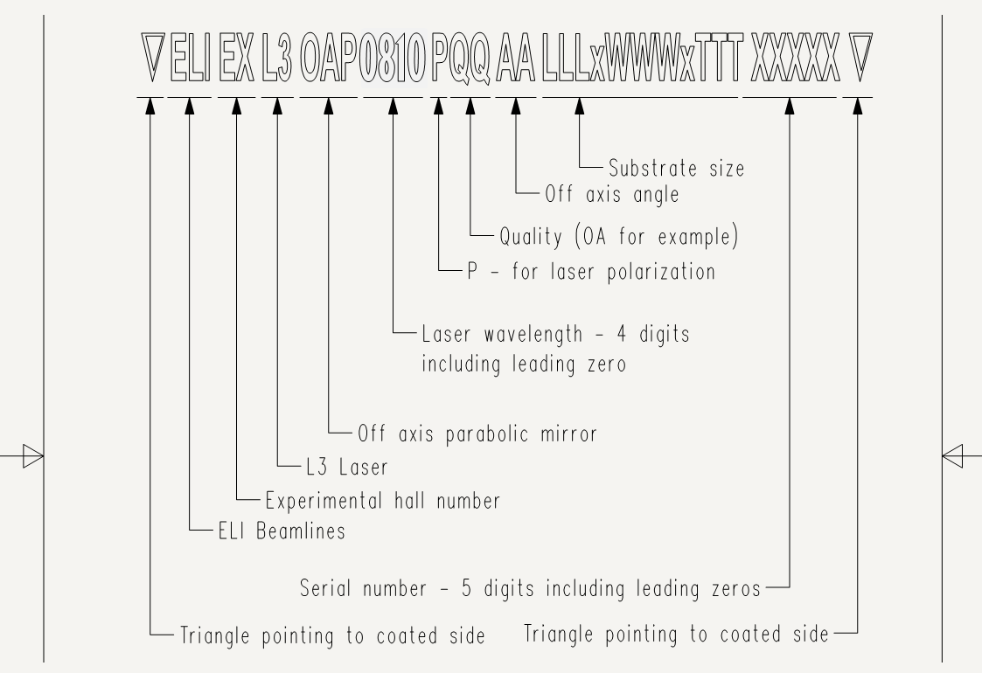
Figure 1: Marking scheme of the Spherical mirror (Instead of the OAP, there should be the SPM).

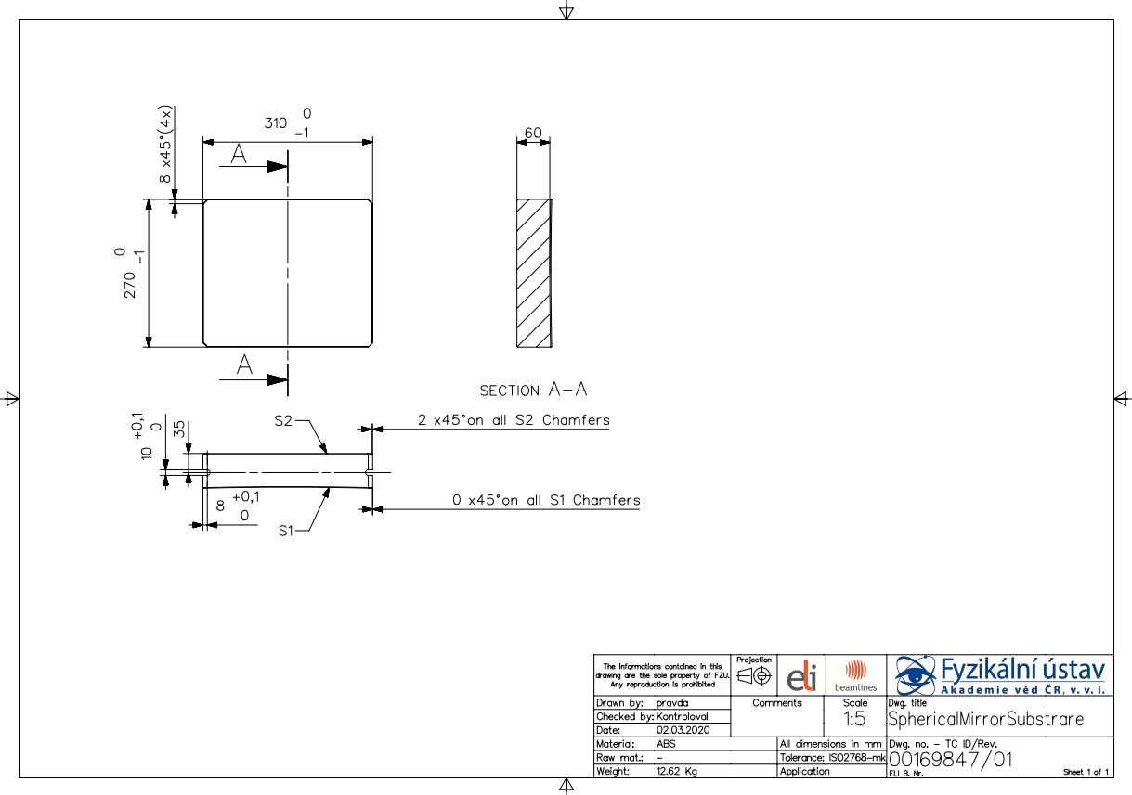

Figure 2: Overview of the SP mirror drawing: PD = 310x270 mm², CAP = 250x250 mm², ROC = 10000 mm (see chapter 1.4; RD-01).

Requirement TC ID / Rev. | Parameter / Property  of the SP mirror | Specified value / Requirement | Quality report (see REQ-028651/A ) | Verification Method
REQ-028618/A | Material | ULE, Zerodur, fused silica, high-power laser compatible or equivalent quality material | V. Substrate material report or certificate | R - review
REQ-028619/A | SP mirror shape  (along the beam) | Rectangular in shape: (310+0-1) x (270+0-1) mm² | VII. Dimensional report | R – review  T - test
REQ-028620/A | Clear aperture | Squared with dimensions at least  250x250 mm² and with rounded corners | - | R - review  T - test
REQ-028621/A | Center thickness | (60±1) mm | VII. Dimensional report | R – review  T - test
REQ-028622/A | Radius of Curvature (ROC) | (10000±20) mm | - | R – review  T - test
REQ-028625/A | Front (i.e. reflective) surface | Protected Au coating | VI. Coating material report | R - review
REQ-028626/A | Coating damage threshold | ≥ 150 mJ/cm², 1000-on-1 @ 10 Hz @ 30 fs (central wavelength 820 nm) | - | R – review  A - analysis
REQ-028627/A | Reflectivity | ≥ 95 % over the range of 766 ≤ Δλ ≤ 854 nm (with best efforts to provide the reflectance homogeneity over the clear aperture of the mirror) | II.Reflectivity measurement report | R - review  T - test
REQ-028628/A | Surface accuracy | ≤ λ/10 peak-to-valley over at least 95 % of clear aperture under test wavelength of (633±2) nm | I.Interferometric report | R - review  T – test
REQ-028629/A | RMS reflected wavefront error | ≤ λ/20 RMS (Power term removed) | I.Interferometric report | R - review  T - test
REQ-028630/A | Surface slope error | ≤ 2.5 µrad under test wavelength of (633±2) nm | I.Interferometric report | R - review  T - test
REQ-028631/A | Surface quality,  Scratch/Dig (S/D) | ≤ 60/40 S/D per MIL-PRF-13830B  (with best efforts: 40/20 S/D) | IV.Surface quality report | R - review  T - test
REQ-028632/A | Group Delay Dispersion (|GDD|) | ≤ 30 fs² for the range of 766 ≤ Δλ ≤ 854 nm | III.|GDD| estimation report | R - review  A - analysis
REQ-028633/A | Microroughness | < 2 nm (after coating) | I.Interferometric report | R – review  T – test
REQ-028636/A | Operational conditions | Vacuum compatible under vacuum level up to 10⁻⁶ mbar without materials outgassing | - | R - review  A - analysis
REQ-028637/A | Chamfers | According to the drawing RD-01  (see chapter 1.4) | VII. Dimensional report | R – review,  T - test
REQ-028638/A | Lateral side | Mounting interface in form of a groove along 2 vertical sides according to the drawing RD-01 (see chapter 1.4) | - | R - review  I – inspection

Table 2: Summary of the specifications for the SP mirror

Environmental requirements

REQ-028645/A
The Supplier and the CA shall agree on the cleaning method to clean the SP mirror without decreasing the mirror’s properties and to avoid contamination of clean space.
NOTE: The cleaning methods may use high gas flow (dry and clean air or N₂) and specialized chemical cleaning liquids (alcohol, Isopropyl alcohol, demineralized water).
Verification method: R - review

Delivery requirements

REQ-028646/A
The transportation to the final destination of the SP mirror shall be conducted by the Supplier.
NOTE: The Supplier is fully responsible for the delivery of undamaged SP mirror.
Verification method: I - inspection
REQ-028647/A
The SP mirror shall be delivered in a protective container – preferably a Polyethylene Terephthalate Glycol (PETG) container – that shall not contact the coated CAP of the SP mirror and prevents its damage, degradation and contamination. The container shall then be sealed with ultra-low outgassing clean room tape and wrapped into 2 aluminized clean room 100 compatible polythene bags. Packaging shall be performed in an ISO class 6 or better clean room environment 6 according to ČSN EN ISO 14644 (or equivalent, e.g. EN ISO 14644).
Verification method: I – inspection, R – review
REQ-028648/A
The Supplier shall provide an appropriate shipping crate with shock and tit watch and packaging material compliant for overseas shipping.
Verification method: I – inspection
REQ-028649/A
The serial number shall be clearly marked on the outer layer of the bubble wrap. The aluminized bag shall have the label: “To be opened only in a clean room class ISO 6 or better and by trained personnel as well as "FRAGILE – GLASS".
NOTE: The same labels should be applied on the outside of the shipping crate/box.
Verification method: I – inspection

Safety Requirements

REQ-028650/A
The Supplier shall supply a Declaration of Conformity or any other equivalent document legally recognized and accepted in the Czech Republic for each product type if the appropriate legislation determines the Supplier's obligation to have a Declaration of Conformity (or the equivalent document) for the purposes of a Device sale in the Czech Republic to fulfil the requirements of 2001/95/EC directive or applicable Czech law.
Verification method: I – inspection

Quality control

Quality Reports (QRs)

REQ-028651/A
The Supplier shall perform a factory verification of the SP mirror and provide corresponding specific quality reports (I - VII) proving that the requirements have been met:
- Interferometric report before and after coating of the SP mirror surface with a map showing a departure from the ideal reflected wavefront in units of testing wavelength λ and/or nm as well as wavefront RMS, gradient and mid spatial frequencies (see REQ-028628/A, REQ-028629/A, REQ-028630/A and REQ-028633/A).
- Reflectivity measurement report of the central area over the specified bandwidth Δλ (see REQ-028627/A) or of the witness sample at ambient humidity as well as at < 2% RH.
- GDD measurement or estimation report.
NOTE: The report may be carried out by the Supplier via measurements performed or calculation or simulations including the description of the estimation method (see REQ-028658/A).
- Surface quality report with scratch and dig map showing the locations of all defects (see REQ-028631/A).
- Substrate material report or certificate showing what is the material of the substrate (see REQ-028618/A).
- Coating material report or certificate showing what is the material of the coating (see REQ-028625/A).
- Dimensional report providing information about a measured physical dimension of the manufactured product (see REQ-028619/A, REQ-028621/A and REQ-028637/A).
NOTE 1: The results of the factory verification of the SP mirror shall be provided to the CA in the corresponding specific QRs before mirror delivery.
NOTE 2: The results shall be in print as well as in digital format.
Verification method: R - review of report, I – inspection

Documentation and data control

REQ-028652/A
The Supplier shall provide Instructions for use (Product User Manual) as part of the delivered Product. The manual shall include the instructions and descriptions regarding the following:
- transport, handling, storage and cleaning;
- safe operation and maintenance procedures.
Verification method: R - review, I - inspection
REQ-028653/A
The Supplier shall supply the following relevant manufacturing documents:
- all approved by the CA manufacturing drawings, 3D models and design supporting documentation;
- all approved by the CA “requests for deviation/wavier from requirements described herein”;
NOTE: The manufacturing documents may be supplied in electronic form in relevant data formats described in the REQ-028656/A.
Verification method: I - inspection
REQ-028654/A
The manufacturing documents shall contain strictly the units which are used to define the requirements in chapter 3.
Verification method: R - review
REQ-028655/A
The manufacturing documents shall include the accuracy of the manufacturing process. This accuracy shall be also included in the corresponding QRs (see REQ-028651/A).
NOTE: The Supplier will specify what can be the maximal difference between the specified parameters (in chapter 3) and the parameters of the final product.
Verification method: R - review
REQ-028656/A
The Supplier shall use following data formats:
- *.JPG, *.PNG, *.TIFF, *.PDF/A, *.HTML
- CAD 2D: *.dwg
- CAD 3D: *.stp; *.ste; *.step or other 3D CAD formats agreed with the CA
- text processors *.doc, *.docx, OpenDocument Format
- spreadsheet processors *.xls, *.xlsx, OpenDocument Format
- presentations *.ppt, *.pptx; OpenDocument Format.
Verification method: Not To Be Tracked within VCD

Nonconformity Control System

REQ-028657/A
The Supplier shall establish and maintain a nonconformity control system compatible with ČSN EN ISO 9001 (or equivalent, e.g. EN ISO 9001).
Verification method: Not To Be Tracked within VCD

Verification requirements for the Supplier

Verification methods

REQ-028658/A
The verification shall be accomplished by the Supplier through one or more of the following verification methods:
- Review; Verification via Review (R) shall consist of using approved records (examples of such approved records are design documents and reports, technical descriptions, and engineering drawings, manuals and accompanying operation documentation) or evidence that unambiguously shows that the requirement is met.
- Inspection; Verification via Inspection (I) shall consist of a visual determination of physical characteristics including photographs taken by the Supplier and sent to the CA proving that the specific requirements have been met.
- Test; Verification via Test (T) shall consist of measuring product performance and functions under realistic operating conditions.
- Analysis; Verification via Analysis (A) shall consist of performing theoretical or empirical evaluations (e.g. mathematical models, calculations and etc.).
Verification method: Not To Be Tracked within VCD

Verification Control Document (VCD)
Verification Control Document (VCD) is a living document which shall be used throughout the entire Contract delivery and its phases (see chapter 7.5 Phasing of the delivery). The VCD provides traceability during delivery phases (Qualification of Design, Manufacturing, Acceptance, etc.).

The VCD represents a formal tool of communication between the Supplier and the CA (formal record, reporting tool).
The VCD will be provided by the CA and it can be accommodated to the Supplier’s needs.

REQ-028659/A
The Supplier shall provide a Verification Control Document (VCD) for the reviews as agreed with the CA.
NOTE 1: Guidelines for VCD preparation will be provided by the CA (see chapter 1.4; RD-02).
NOTE 2: The form of VCD will be agreed between the CA and the Supplier based on the best commercial praxis used by the Supplier.
NOTE 3: The form of VCD will be agreed before completion of the Qualification Design phase (see chapter 7.5.1).
NOTE 4: The VCD specifies HOW and WHEN each requirement is planned to be verified by the Supplier, when it was actually verified.
Verification method: R - review

Phasing of the delivery

This chapter is intended to briefly summarize basic milestones of the Contract delivery. These milestones represent gates (checkpoints) where the quality of the delivery is to be evaluated.
Delivery shall not proceed past these gates unless their satisfactory accomplishment is approved by the CA.
Delivery lifecycle shall contain at least the following phases (quality gates):
- Qualification of Design;
- Manufacturing;
- Acceptance.

Qualification of Design

Summary of what has to be provided by the Supplier in terms of documentation (QRs and manufacturing drawings) before starting the manufacturing. The goal is to verify the manufacturing drawings and design supporting documentation.

The output of this phase is Qualified Design and agreed scope of technical documentation.

REQ-028660/A
Before completion of the Qualification Design phase the Supplier shall provide following information that shall be agreed by the CA:
- structure and content of the Quality Reports (QRs, see
REQ-028651/A);
- structure and content of the VCD ready to be implemented (see REQ-028659/A).
Verification method: R - review

REQ-028661/A
Before completion of the Qualification Design phase the Supplier and the CA shall agree on:
- final manufacturing drawings provided by the Supplier (see REQ-028653/A);
- detailed procedures related to the testing during Manufacturing phase (see chapter 7.5.2 Manufacturing);
- common nonconformity control system (see REQ-028657/A).
Verification method: R - review

Manufacturing

The goal is to demonstrate that the manufactured product meet the specified technical requirements (RSD) of the CA.

This quality gate concerns primarily:
- Inspection of manufactured product;
- Testing at the Supplier’s site (factory testing);
- Cleaning, Packaging and shipping.
Output of this phase is the Verified Final Product.

REQ-028662/A
The results of the Manufacturing phase of verification shall be recorded by the Supplier in the appropriate QRs (or in other factory/quality reports, if not specified in chapter 7.1) and overall results (including review of documentation/reports and inspection of product) shall be recorded in the VCD (see chapters 7.4.2).
NOTE: The results of all the tests shall be given strictly in units which are used to define the requirements in chapter 3.
Verification method: R - review
REQ-028663/A
The final issue of the VCD shall be submitted to the CA after the approval of the last report and before starting the acceptance (see chapter 7.5.3).
Verification method: R - review

Acceptance

Acceptance will be carried out by the CA upon delivery of the final product not obviously damaged during transport. The basis for acceptance will be completed VCD summarizing the overall verification results together with relevant documentation supporting the verification (i.e. QRs, approved manufacturing drawings and 3D model, Product User Manual and etc.).

In case of successful acceptance phase, the CA will provide to the Supplier signed acceptance protocol. In case of unsuccessful acceptance stage the CA will provide to the Supplier Nonconformity Report (NCR) and process in accordance with REQ-028657/A shall be applied.

REQ-028664/A
The Acceptance phase shall demonstrate the following:
- The final product has been successfully verified by the Supplier and the results of this process have been documented in an appropriate way through QRs (see chapter 7.1) and VCD (see chapter 7.4.2);
- All detected nonconformities have been solved in accordance with REQ-028657/A;
- The final product is free of fabrication errors and is ready for the intended operational use.
Verification method: Not To Be Tracked within VCD

